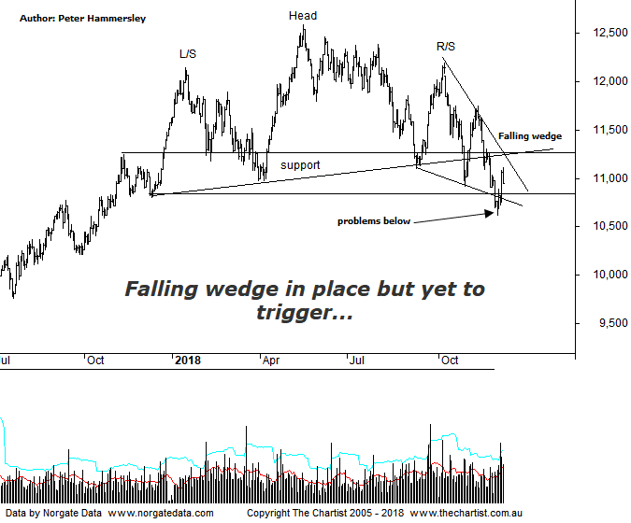

Bottom Line
4/12:
Daily Trend: Up
Weekly Trend: Down
Monthly Trend: Down
Support levels: 10617 / 9322 / 8301 / 7774
Resistance levels: 12585 / 13059 / 15093
Video Analysis
Watch Video Analysis Here
Technical Discussion
The Materials sector has declined just over 15% off the 17th of May high. However, although this is significant it’s hardly put a dent into the trend that commenced all the way back in 2016, where price rallied well over 100%. The big question now is whether a deeper retracement needs to unfold before the longer-term uptrend resumes. We have been focusing on the weekly chart recently and although we will refresh our memories within the video this evening, tonight we’ll concentrate on the daily timeframe and the more recent price action. First of all, it would fair to say that the big miners like BHP and RIO have remained resilient over the past few months whilst many stocks we cover have been embarking on strong impulsive legs South. This can only be viewed in a positive light although it doesn’t necessarily portend longer-term strength from current levels. However, as long as price action remains choppy and messy to the downside, the risk of something more sinister unfolding remains low. Also, on the positive side of things, the big miners have made some large discoveries recently with BHP being a good example just a few days ago. Some of the mid-cap producers have also started exploration in earnest recently which ideally is a trait that will continue as it’s a sign of confidence. According to RBC Capital, those with capital plans that can rekindle growth are likely to outperform.
Reasons to be more optimistic (caution short-term):
→ Economic growth is anticipated following Donald Trump’s victory which should be supportive of commodity prices.
→ Chinese consumption appears to be holding.
→ Investors’ appetite for risk has been increasing.
→ Small resource stocks have retraced following a reasonable leg higher.
→ Price has broken through major resistance.
→ Retesting a new zone of support.
There are a couple of reasons for concentrating on the daily chart this evening. First of all we have a falling wedge, which as we’ve stated many times before are one of our favourite reversal patterns. These are known as Ending diagonal triangles in Elliott terms and usually prove to be significant. This isn’t quite a textbook example as it doesn’t contain 5-internal swings although the basic pattern is clear to see and as such it deserves recognition. Also note that the lower trend line was recently overcome which is known as a “Throwover” and is something that often occurs. The lower boundary of the wedge also coincides with the lower boundary of the horizontal line of support providing some much-needed confluence. The bottom line is, if we are to see a leg higher then now is as good a time as any for it to kick into gear. Technically the upper boundary of the wedge needs to be overcome before the pattern triggers which is something we’ll be looking out for over the coming weeks. The other pattern of interest on the smaller timeframe is the Head & Shoulders. The neckline has already been overcome meaning the pattern has triggered. We’ve pencilled in the target by measuring the depth of the pattern and projecting it from the breakout which should take price to around 9700. This sits just above the typical retracement zone of the whole leg higher off the 2016 lows. That lower target sits either side of 9000 and would be the worst-case scenario although there is no point focusing on that area at this early stage. Essentially what we have are conflicting signals, with the H&S projecting a much deeper retracement, whilst the falling wedge and zone of support offer a more bullish outcome. We’ll take one step at a time and see if the upper boundary of the wedge can be overcome as this would be a step in the right direction regarding avoiding the deeper retracement.
Trading Strategy
We currently don’t have exposure to the sector although we are still open to putting forward recommendations when the patterns permit. If price gets through the upper boundary of the falling wedge, we’ll be much more confident regarding a multi-week trend unfolding. With these types of patterns, price will normally head toward the origin of the structure which in this instance sits just above 12000 and is a good percentage gain from current levels. We have a few stocks on the watchlist within the sector with BHP being one that immediately comes to mind. For now, a little more patience is required.

