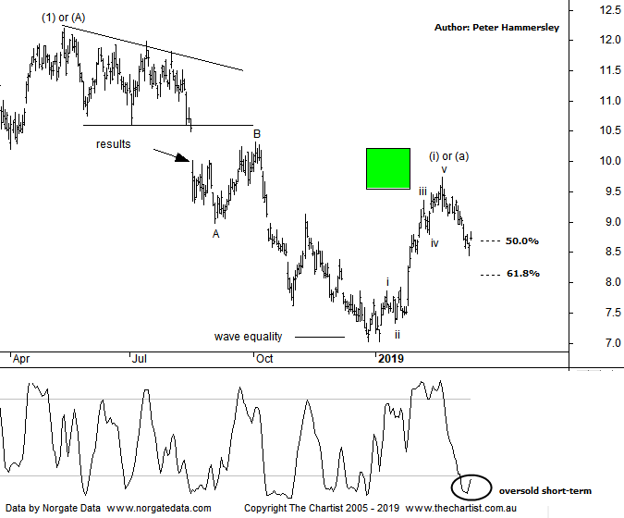

Bottom Line
14/3:
DailyTrend: Down
Weekly Trend: Up
Monthly Trend: Down
Support Levels: $7.02
Resistance Levels: $9.74 - $10.20 / $12.08 - $12.23
Video Analysis
Watch Video Analysis Here
Technical Discussion
Iluka Resources (ILU) is an Australia-based mineral sands company. It is involved in mineral sands exploration, project development, operations and marketing. The company’s sections include Australia (AUS), Sierra Rutile (SRL), United States (US) and Mining Area C (MAC). The AUS section consists of the mineral sands mining and processing operations in Victoria, Western Australia and South Australia. The material is mined from numerous deposits in Western Australia (Perth Basin), together with the Jacinth-Ambrosia deposit in South Australia (Eucla Basin) and various deposits in Victoria (Murray Basin. For the year ending the 31st of December 2018 revenues increased 25% to A$1.35B. Net income was A$303.9M against a loss of A$171.6M. Revenues highlight the Australia section increase of 26% to A$1.05B, the Sierra Rutile section increase of 47% to A$210.9M, the China section increase of 39% to A$462.3M and the Americas section increase of 74% to A$230.7M. Net Income shows Impairment of assets decreased from A$185.3M. Broker consensus is currently “Buy”. The dividend yield stands at 3.4%.
Reasons to be more optimistic:
→ Good price increases for zircon and rutile.
→ Australian operations continue to deliver.
→ Capital expenditure guidance for 2019 is below consensus.
→ Brokers see upside risk from rutile prices moving forward.
→ Price rebounded strongly from a potential reversal zone.
→ Mineral sands market conditions are recovering as demand improves.
→ Strong market conditions driven by reduced inventory in the system and a stable demand environment.
→ An increase in the titanium dioxide price could be the trigger for an upside break.
Brokers are unanimously bullish on the prospects for ILU although interestingly almost all cite the possible sell-down of 10% of Sierra Rutile as being a possible stumbling block, especially as the price appears to be lower than valuation. All that said, we couldn’t have asked for too much more following our last review where price had tagged the wave equality projection before reversing higher. We had our “bounce zone” firmly in place either side of $10.00 which as can be seen has been tagged. Had we seen a corrective pattern into the target area we’d have been looking for another significant leg South although this clearly isn’t the case. It’s been a strong impulsive movement higher and although weakness has been the main theme over the past three weeks, we believe the risk is to the upside over the medium to longer-term. Zooming into the more recent price action shows that the typical retracement zone of the prior leg north has already been tagged meaning if we are to see a leg higher then now is as good a time as any for it to kick into gear. I would only become concerned should the 61.8% retracement level at $8.06 be overcome during the current retracement. The further price gets down through the typical retracement zone, the greater the chance that the patterns are going to morph into something less bullish which is something that needs to be avoided. A quick look at the weekly chart (not shown) shows a solid line of resistance up around $12.00 which will need to be overcome before getting overly excited longer-term although this still offers a large percentage gain from current levels, irrespective of whether that line in the sand can be breached. For now, let’s see if some demand appears as this would lock in wave-(ii) or-(b).
Trading Strategy
Having hit the typical retracement zone you could use our SaR indicator as a trigger mechanism which currently sits at $9.14. Just remember price needs to close above the indicator before initiating long positions. The protective stop will need to be placed just beneath the prior pivot low, or just beneath the 61.8% retracement level at $8.06 if you want to allow more wiggle room. I’m going to make a formal recommendation this evening in the position status page.

