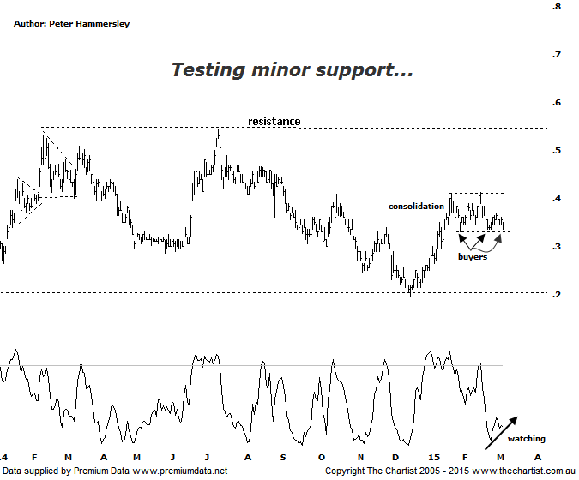

Bottom Line
6/3:
Daily Trend: Neutral
Weekly Trend: Neutral
Monthly Trend: Neutral
Support levels: $0.33 / $0.275
Resistance levels: $0.41 / $0.545 / $0.915
Video Analysis
Watch Video Analysis Here
Technical Discussion
Perseus Mining is a Gold & Silver explorer which went on to become a producer in early 2012. It operates in the republics of Ghana and Cote d’Ivoire in West Africa. The Sissingue Gold project is located within an 885 square kilometre land package consisting of the Sissingue exploitation permit area and the adjoining Tengrela south exploration permit area. Together they are known as the Tengrela Gold project. Broker consensus is currently “Hold”. For the six months ending the 31st of December 2014 revenues increased 5% to A$142.2M. Net income totalled A$40.5M vs. loss of A$3.8M. Revenues reflect an Interest Revenue increase from A$25K to A$313K
Reasons to be ready to buy:
→ Currency gains resulted in an improved first-half result.
→ The balance sheet is healthy with no debt.
→ Perseus continues to cut expenditure which is required for the company to keep profitable.
→ A line of resistance is being challenged.
An update on the power problems at the Edikan mine didn’t have too much of a negative effect today which can only be viewed as a positive considering that production is going to be affected. However, price has been falling over the past few weeks which is almost certainly down to the retracement in gold itself. Quite interestingly, results announced on the 16th of February were met with some enthusiasm with the end result being a solid percentage gain accompanied by high volume. Unfortunately that strength proved to be a one off event with price rejecting from the line of resistance as annotated. This means that the ascending triangle we were keeping close tabs on has been invalidated which is really something we didn’t want to see. Not that this moves us to a bearish stance although a break beneath the minor line of support around current levels would be reason for concern, at least over the short term. Should minor support hold it could well be that the sideways consolidation that’s been unfolding since January is a longer pause for breath before the next leg higher. That would be the ideal situation although as previously mentioned at the end of the day Perseus is probably going to follow the price of the yellow metal itself which has been struggling of late. Should the next move be to the downside we need to keep a close eye on the 61.8% retracement level of the prior leg higher which sits at $0.275; a break beneath that level would likely result in the significant lows made in mid-December of last year being revisited.
Trading Strategy
I’d only be interested in a trade here if the lower boundary of the consolidation pattern is penetrated intraday followed by a strong close. The reason being that there is the possibility of seeing some Type-A bullish divergence in a few days time though the ideal set-up would have to present itself before getting involved. Any trade put forward next week would also be for aggressive traders only with the more conservative amongst you needing to stand aside. Should the bullish divergence trigger we’ll be looking for a continuation up toward the line of resistance circa $0.54 which offers a good percentage gain from current levels. For the moment it’s one for the short-term watch list.

