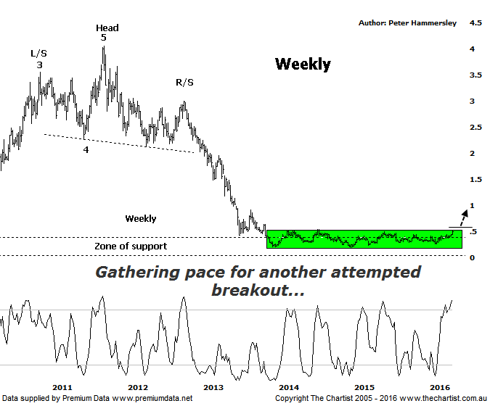

Bottom Line
20/4:
Daily Trend: Up
Weekly Trend: Up
Monthly Trend: Up
Support levels: $0.42 / $0.36
Resistance levels: $0.545 / $0.915
Video Analysis
Watch Video Analysis Here
Technical Discussion
Perseus Mining is a Gold & Silver explorer which went on to become a producer in early 2012. It operates in the republics of Ghana and Cote d’Ivoire in West Africa. The Sissingue Gold project is located within an 885 square kilometre land package consisting of the Sissingue exploitation permit area and the adjoining Tengrela south exploration permit area. Together they are known as the Tengrela Gold project. For the six months ending the 31st of December 2015 revenues increased 5% to A$149.1M. Net income decreased 70% to A$12.1M. Revenues reveal an increase in demand for the Company's products and services due to favorable market conditions. Broker consensus is currently “Hold”. No dividend is currently paid.

Reasons to be more optimistic longer term:
→ Improved reliability and increased cash generation in West Africa.
→ Management have indicated that mine life at Edikan has been increased.
→ The Ghanaian government has given approval for access to additional mining areas.
→ Currency gains resulted in an improved result.
→ The balance sheet is healthy with no debt.
→ Perseus continues to cut expenditure which is required for the company to remain profitable.

This is our first review of Perseus since late last year although we can clearly see the reason why we haven’t wanted to be involved. This is the weekly chart this evening which shows the long drawn-out consolidation phase that’s been unfolding since late 2013. Not great if you’re a holder of the company although the lacklustre price action provides an opportunity for those wanting to be involved. Like many of the smaller mining companies it has been smashed over the years but there are positive aspects of the chart that need taking a look at. The sideways move has formed a basing pattern which is something that’s usually required when technical damage has been inflicted. Also, we can see the massive increase in volume that commenced in June 2013 as buyers stepped up to the plate in numbers. This didn’t trigger a leg higher but it is a sign that the smart money was starting to dip their toes in. Eventually this should result in a strong leg higher; the question of course is when that strength is going to materialise. There is no cast-iron way of determining when this time will be although what we do now is that price is posturing in exactly the right place at this juncture. Volume has also been picking up over the past couple of weeks which means a serious attempt at breaking through the upper boundary of the basing pattern is about to take place. Today saw initial strength sold into so it will be interesting to see what transpires throughout the rest of the week and into next. Some high closes need to be witnessed although today’s high came within a whisker of the significant highs made in July 2014. Indeed, a push up through that level at $0.545 with some degree of attitude is required if a multi-month trend higher is going to kick into gear.
Trading Strategy
The only problem for the moment is bearish divergence evident on the daily chart (not shown) although it’s yet to trigger. However, having seen today’s rejection of higher prices it could well be that a little more time is required before the breakout transpires. Whichever way you look at it, this is a trade for the more aggressive with the strategy being to buy following a break up through $0.545. We’ll place the initial stop just beneath what then becomes new support at $0.46. The measured move out of the basing pattern provides a target at $0.90 although if gold can gain a head of steam we’ll be looking for substantially higher levels to be tagged which we’ll discuss later down the track if some traction can be gleaned.

Disclosure: Peter Hammersley / Nick Radge hold.

