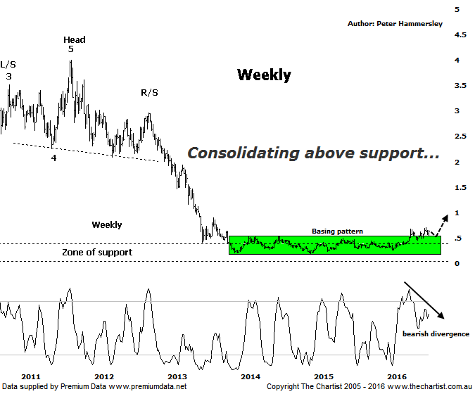

Bottom Line
28/7:
Daily Trend: Up
Weekly Trend: Up
Monthly Trend: Up
Support levels: $0.45 - $0.42 / $0.36
Resistance levels: $0.70 / $0.915
Video Analysis
Watch Video Analysis Here
Technical Discussion
Perseus Mining is a Gold & Silver explorer which went on to become a producer in early 2012. It operates in the republics of Ghana and Cote d’Ivoire in West Africa. The Sissingue Gold project is located within an 885 square kilometre land package consisting of the Sissingue exploitation permit area and the adjoining Tengrela south exploration permit area. Together they are known as the Tengrela Gold project. For the six months ending the 31st of December 2015 revenues increased 5% to A$149.1M. Net income decreased 70% to A$12.1M. Revenues reveal an increase in demand for the Company's products and services due to favorable market conditions. Broker consensus is currently “Hold”. No dividend is currently paid.
Reasons to remain optimistic longer term:
→ Improved reliability and increased cash generation in West Africa.
→ Management have indicated that mine life at Edikan has been increased.
→ The Ghanaian government has given approval for access to additional mining areas.
→ Currency gains resulted in an improved result.
→ The balance sheet is healthy with no debt.
→ Perseus continues to cut expenditure which is required for the company to remain profitable.

Plenty of gold stocks have been trending with a degree of attitude over the past few months with SBM & RRL two that immediately come to mind. In fact, many of the miners in the sector have broken up through large consolidation or basing patterns which often triggers strong impulsive price action. However, there are also several other companies sitting within the sector that have yet to break out with any impetus. PRU fits into the latter category with a few failed attempts taking hold this year. The smaller degree patterns are still difficult to decipher which means we’ll go back to the weekly chart this evening and remind ourselves that the large consolidation phase that commenced all the way back in December 2013 is extremely bullish medium to longer term. Indeed, the upper boundary of the basing pattern has been overcome with price recently posturing above what essentially becomes new support. Yes, we are still waiting for the longer term uptrend to kick into gear although it only appears to be a matter of time before this is witnessed. Of course timing is extremely important although sometimes you just have to be patient. In regard to the basing pattern we can measure the depth of the structure and project that distance higher from the breakout area which in this instance provides a target just beneath $1.00 although this would be our minimum expectation. If the yellow metal can really gain a head of steam, then the typical retracement zone of the whole leg down off the all-time highs well above $2.00 is attainable although it could take several years to reach those heights. For now, we’ll take one step and one pattern at a time whilst continuing to show patience.
Trading Strategy
Perseus isn’t alone in regard to us waiting for a more impulsive breakout with AQG being one that we’ve added to our menu, and our watchlist recently. Both stocks have the potential to make substantial gains and find themselves sitting within very similar patterns. One thing is for sure, short-term volatility is unlikely to go away meaning we have to be even more vigilant in regard to finding low risk entries. However, we have jumped onto a few of the gold stocks recently though have taken profits off the table. When the time is right, and patterns permit, we’ll be putting more setups forward.

Disclosure: Peter Hammersley / Nick Radge hold.

