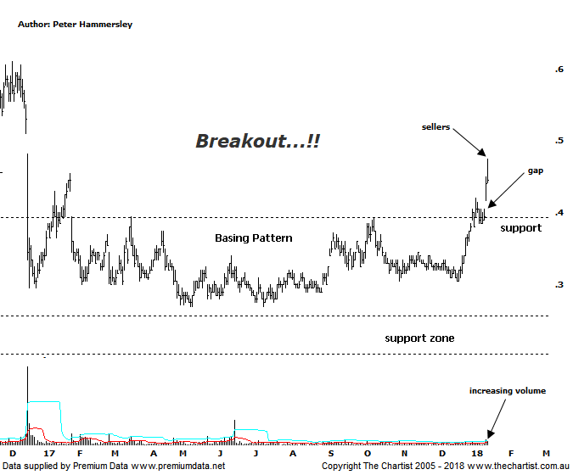

Bottom Line
16/1:
Daily Trend: Up
Weekly Trend: Up
Monthly Trend: Up
Support levels: $0.39 - $0.37 / $0.27
Resistance levels: $0.70 / $0.915
Video Analysis
Watch Video Analysis Here
Technical Discussion
Perseus Mining is a Gold & Silver explorer which went on to become a producer in early 2012. It operates in the republics of Ghana and Cote d’Ivoire in West Africa. The Sissingue Gold project is located within an 885 square kilometre land package consisting of the Sissingue exploitation permit area and the adjoining Tengrela south exploration permit area. Together they are known as the Tengrela Gold project. For the year ending the 30th of June 2017, revenues increased 12% to A$283.3M. Net loss increased from A$35.6M to A$76.2Ms. Basic Earnings per Share excluding Extraordinary Items decreased from -A$0.06 to -A$0.07. Broker consensus is currently “Buy”. No dividend is paid.
Reasons to remain optimistic longer term:
→ The Yaoure gold project feasibility study has confirmed an additional 8.5-year mine life.
→ The Sissingué Gold Mine in Côte d’Ivoire is close to completion and ahead of schedule.
→ Potential to increase Sissingué’s mineral resources, or reserves and mine life.
→ Edikan is back on track following plant upgrades.
→ Price has just broken up through a zone of support in an impulsive manner.
Our last look at PRU was back in September 2016 although a quick glance at the chart shows why we haven’t wanted to be involved. Until recently price action has been extremely choppy and messy although on the positive side of things this has resulted in the formation of a basing pattern. The strong break through the upper boundary of that pattern is what’s made us sit up and take notice. Price was already posturing for a breakout last week although an announcement yesterday regarding a gold project was the trigger for the gap higher and the large percentage gain. There was follow-through today albeit the close was off the sessions highs. In a perfect world we’d like to see price come back to at least fill the gap left yesterday, and potentially head down to the old line of resistance which should now be acting as support. We must also be cognizant of the price of gold which has been looking stronger recently. This has flowed through to many of the miners we follow with some patterns taking a serious turn for the better. A higher price for the yellow metal coupled with the recent positive announcements can only be a good recipe and opens the door for a decent trend higher to develop. A quick look at the weekly chart (not shown) shows that price has been consolidating since late 2013 although the upper boundary of that range sits slightly higher around $0.70 which is still well above current levels. For now though, we’ll concentrate on the smaller congestion pattern which portends a push up toward $0.55, being the measured move. My only real concern is once again bearish divergence although it’s yet to trigger. One thing is for sure, another few days of strength will invalidate this bearish pattern. Should it prove to be significant then the retracement back down toward the new zone of support will likely come to fruition. Either way, the patterns are looking much better than they have for many years.
Trading Strategy
You could accumulate partial positions right here and now although with the bearish divergence coupled with the gap that’s been left I wouldn’t go the full hog. Also, as it stands the protective stop will need to be placed just beneath the new zone of support around $0.38. Should price come back to retest the breakout area over next week or two we’ll be looking for an entry, albeit the prerequisite is that the bearish divergence unwinds or invalidates. There is no formal recommendation yet but I’m keen to put a trade forward as soon as is practically possible.

Disclosure: Peter Hammersley / Nick Radge hold.

