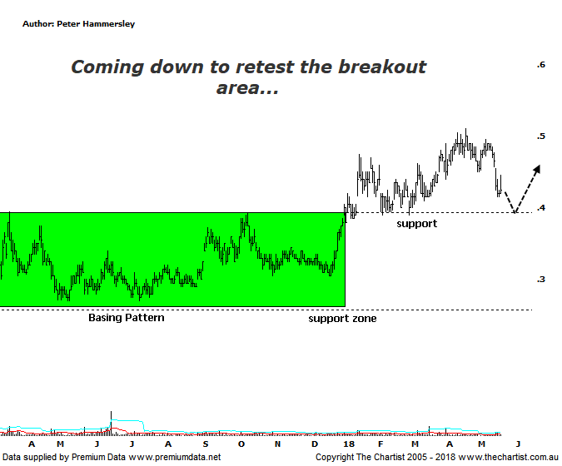

Bottom Line
21/5:
Daily Trend: Down
Weekly Trend: Down
Monthly Trend: Up
Support levels: $0.39 - $0.37 / $0.27
Resistance levels: $0.70 / $0.915
Video Analysis
Watch Video Analysis Here
Technical Discussion
Perseus Mining is a Gold & Silver explorer which went on to become a producer in early 2012. It operates in the republics of Ghana and Cote d’Ivoire in West Africa. The Sissingue Gold project is located within an 885 square kilometre land package consisting of the Sissingue exploitation permit area and the adjoining Tengrela south exploration permit area. Together they are known as the Tengrela Gold project. For the six months ending the 31st of December 2017, revenues increased 51% to A$167.8M. Net loss decreased 46% to A$12.1M. Revenues highlight the Ghana section increase of 41% to A$167.7M. Lower net loss reflects the legal settlement decrease from A$24.1M. Broker consensus is currently “Buy”. No dividend is paid.
Reasons to remain optimistic longer term:
→ Growth potential through a third development at Yaoure.
→ Operating consistency a confidence booster.
→ Being positive net cash by the end of 2018 looking more likely.
→ Successful completion of the Sissingue gold mine.
→ The Yaoure gold project feasibility study has confirmed an additional 8.5-year mine life.
→ Potential to increase Sissingué’s mineral resources, or reserves and mine life.
→ Edikan is back on track following plant upgrades.
→ Price has just broken up through a zone of support in an impulsive manner.
Gold itself has been flattering to deceive recently and now appears to be consolidating beneath $1300 an ounce which could open the door for further declines. As mentioned in Tuesdays review of the Gold sub sector (XGD) there’s no reason to be anything other than bullish longer-term with the patterns on the monthly chart continuing to look promising. Gold in Australian dollar terms has been performing much better which is why the sector over here has been much more robust. In fact, strong trends continue to unfold. In the case of Perseus, we’ve been concentrating on the fact that price has broken higher out of a large basing pattern going all the way back to early 2017. Despite the retracement over the past few weeks the risk is still to the upside, with the prerequisite being that price doesn’t head back into the range. In other words, a push beneath $0.39 would be a step in the wrong direction although it wouldn’t invalidate the bullish case entirely. Ideally, price needs to head up through the recovery high at $0.475 as this would be a big confidence booster and suggest the recent retracement has been nothing more than a healthy pull-back. I haven’t put forward a wave count on this chart which is solely down to the long drawn-out consolidation phase. Once more data becomes available we can start penciling in a smaller degree wave count although until that time presents, we’ll concentrate on more conventional analysis which again brings us back to the basing pattern and the zone of resistance which should now be acting as support.
Trading Strategy
The recent turnaround in gold has resulted in us tightening trailing stops in our 2 gold plays which has resulted in us taking a small loss in PRU. No damage done, and we continue to run with AQG which has continued to head higher whilst most around it have been taking a pause. Regarding Perseus, upside risk remains with the prerequisite being that buyers step up around the zone of support should it come under pressure again. Today wasn’t a good start with initial strength being sold into resulting in a weak close although as always, we can’t read too much into one day’s action. Still on the watchlist, but everything is going to depend on what transpires just beneath $0.40.
Disclosure: Peter Hammersley holds.

