Fortescue Metals Group (FMG)
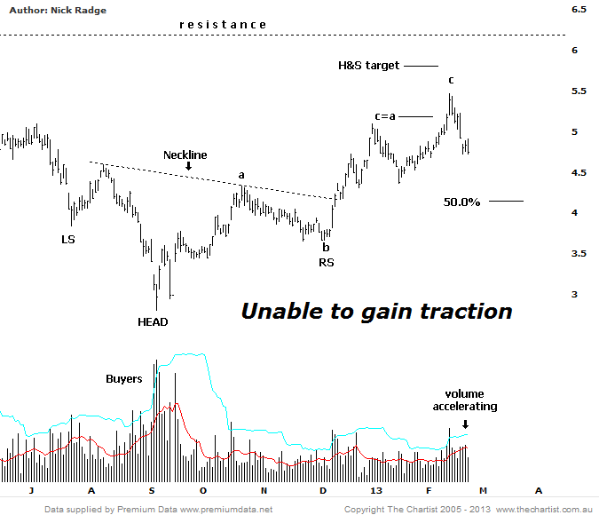
Bottom Line
25/2:
Daily Trend: Down
Weekly Trend: Up
Monthly Trend: Up
Video Analysis Watch Video Analysis Technical Discussion
25/2:
Price may be pushing higher but it's not exactly making a bullish statement. We've had upside expectations since the significant volume lows seen late last year, but this grind higher gives us a round of reasons to think prices will only continue to oscillate higher rather than trend smoothly. Analysts covering the stock have mixed feelings as well; Of the 20 covering FMG, 4 rate it a BUY, 6 as OUTPERFORM, 8 as HOLD and 2 SELL. This is a slightly weaker rating than 3-months ago. Our target remains around the $5.75 area and we're cognizant of the line of resistance just above at $6.25. However, of concern is the increasing volume we're seeing over the last week as prices decline. Normally we like to see dips take place on low volume, usually meaning weaker hands are selling rather than the big end of town. However, increasing volume here means sellers have more motive to exit for wherever reason and suggests near term weakness is probable. There is also some Type-B bearish divergence on the weekly chart (not shown) which also tends to suggest a near term high has been made. With these two factors we expect price to retrace back toward $3.80 - $4.20 being the 50.0% to 61.8% retracement of the up swing. This may offer up a new buying opportunity but we'll need to see certain traits to gain confidence in taking a position. We'll discuss those below.

Divergences come in three flavours; Type-A, -B and -C. These have nothing to do with Elliott Wave theory. Type-A is the strongest and one we always listen to and consider trading. The major low is 2009 occurred on Type-A bullish divergence on a weekly time frame and because it was combined with other technical patterns it was an extremely strong buying signal. We're happy to trade a Type-A on its own merits, but a Type-B is not as strong and we don't tend to follow it unless it occurs in confluence with other patterns. Being a very weak signal Type-C divergence is not given the time of day. There are also other types of divergences known as 'hidden' patterns. For more information on divergences and how we trade then, please go to our Resource Library (Member Dashboard > Resource Library > Articles).
Trading Strategy
25/2:
What we want to see here is a symmetrical a-b-c pattern that takes prices down into our typical retracement zone but its also important that this occurs on declining volume. At present, assuming we're seeing a wave-a lower, we'd like to see wave-c occur on low volume. Only then will we assess an upside trading opportunity. Alternately if we're to get a more sinister downside move we'd be on watch for those same buyers who stepped in during September 2012 and again in December. Until then, stand aside.

