Fortescue Metals Group (FMG)
Chart
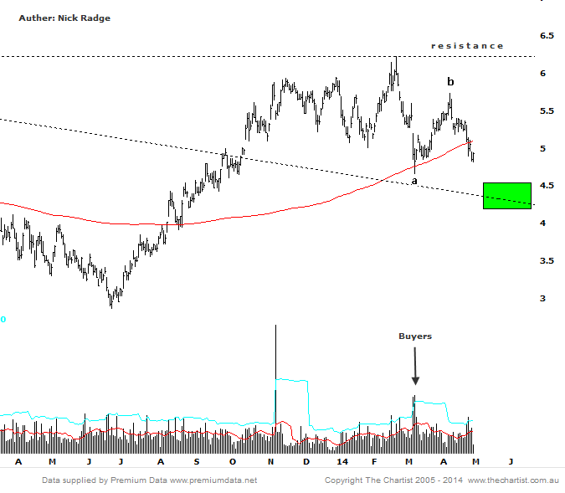
Bottom Line
2/5:
Daily Trend: Down
Weekly Trend: Down
Monthly Trend: Up
Support Levels: $4.66 / $4.25 - $4.36
Resistence Levels: $5.73 / $6.22
Video Analysis
Watch Video Analysis Here
Technical Discussion
Fortescue is an iron ore producer and explorer operating in the Pilbara region of Western Australia. It operates several mines, Cloudbreak, Christmas Creek, Firetail and Kings, as well as integrated rail and port supply chain facilities. The company also holds development properties. The company retains significant risks being relient on China.
Reasons to be bullish:
→ After rapid expansion debt repayment has begun
→ Improving balance sheet will reduce risks during cyclical weakness
→ Price nearing strong buying zone
In our last review we expected ongoing weakness to continue. Prices have declined through the longer term 200-day moving average and is once again below $5.00, although we continue to expect the $4.25 to $4.50 zone to come into play. If so this will offer a strong buying opportunity, although declining volumes will remain key. The last time prices probed into this zone back in March, we saw strong buyer demand enter and therefore expect similar. Upside rewards look very promising. As a minimum we would expect a retest of the recent highs of $6.25. On many occasions a small run through those highs, say to $6.50, would be expected. If a strong trend takes shape we would be looking for $7.60.
Trading Strategy
The strong buyer demand seen back in March could be reason that prices fail to dip into our wanted zone. If you are a firm believer in the prospects of FG, then buying a small parcel right here would be a start, then look to buy more if/when that expected decline does take shape. Alternately, await the $4.25 - $4.50 zone to be met, at which time we'll update the recommendation.

