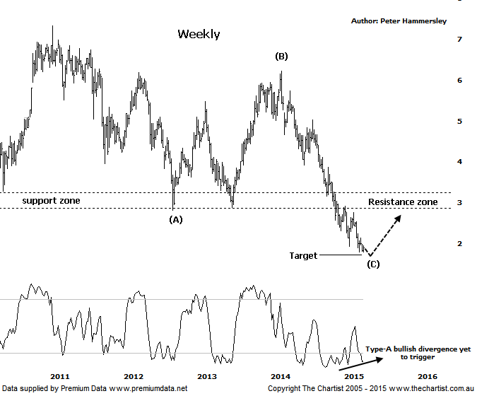

Bottom Line
9/4:
Daily Trend: Down
Weekly Trend: Down
Monthly Trend: Down
Support Levels: $1.69 / $1.16
Resistence Levels: $2.76 / $3.86 / $5.03
Video Analysis
Watch Video Analysis Here
Technical Discussion
Fortescue Metals is an Iron Ore producer and explorer operational in the Pilbara region of Western Australia. It is engaged in mining of iron ore from its Cloudbreak and Christmas Creek mine sites. Its Cloudbreak mine site is located in the Chichester Ranges in the Pilbara region of Western Australia which is 263 kilometres south of Port Hedland and 150km north of Newman. Its Christmas Creek is the second mining operation, 50 km to the east of Cloudbreak. The Company has also designed and constructed rail and port facilities to support the development and sale of the Pilbara's stranded iron ore bodies. For the six months ending the 31st of December 2014 revenues decreased 17% to $4.86B. Net income decreased 81% to $331M. Revenues reveal that the average price per unit of iron ore decreased 47% to $66 per metric ton. Broker/Analyst consensus is currently “Sell”. The dividend yield is 12.7%.
Reasons to remain cautious:
→ Fortescue has scrapped its debt restructuring plans having withdrawn its US$2.5bn debt offering.
→ The price of Iron Ore remains a drag on the share price.
→ No dividend is expected in 2015.
→ The company isn’t expected to be profitable in FY16 or FY 17.
→ Net debt at the end is FY 14 was US$7.2bn which came in under estimates.
→ A line of support has been smashed.
Despite a bounce unfolding following our last look at Fortescue nothing changes with the risk still being to the downside over the short term. In fact we’ve been watching our lower target area at $1.69 over the past few months which is a level that is yet to be tagged. That said, it isn’t going to take too much to head down into that area meaning we can’t take our eyes off the price action over the coming weeks. Remember, in regard to the bigger picture we continue to look for an A-B-C movement down with the wave equality projection being the crux our target. There is also support at those lower levels going all way back to 2008 which increases its significance. We’ll continue to concentrate on the weekly chart which depicts what we are looking for very succinctly. That is a 3-leg movement lower which in an ideal world will complete the whole retracement. However, it would be foolhardy to ignore the main driver for iron ore stocks. This is obviously the price of the metal itself which continues to remain under severe pressure. It’s also very interesting that several big name brokers have jumped ship and are now expecting further severe declines in the price of iron ore itself. They may be correct but the contrarian in me suspects they are jumping on to the bearish bandwagon a little late which could be viewed in a positive light. Back to the chart shows that the bullish divergence we noted during our last review still hasn’t triggered although technically it’s still in position. Interestingly enough though the less potent Type-B bullish divergence has triggered on the daily time frame (not shown). Had our target been tagged we’d much more confident that a low has been locked in; as this clearly isn’t the case we have to remain cautious.
Trading Strategy
Before even thinking in terms of looking for a buying opportunity we need to see clear evidence of demand returning which at this juncture clearly hasn’t transpired. That said, the bullish divergence on two time frames is a step in the right direction and means we need to be on alert for a potential low risk entry. One for the watch list if you are aggressively looking for setups within the sector although the time for jumping on hasn’t quite arrived yet. More patience could be rewarded in the not too distant future with the prerequisite being that our target at $1.69 isn’t penetrated.

