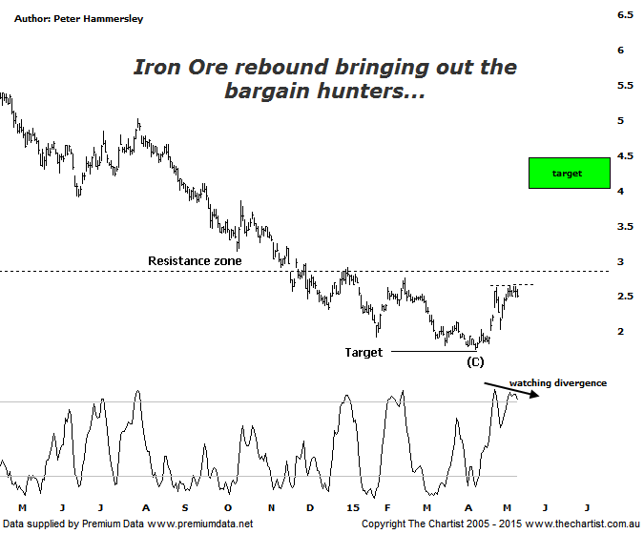

Bottom Line
8/5:
Daily Trend: Up
Weekly Trend: Down
Monthly Trend: Down
Support Levels: $2.26 / $1.75 / $1.69 / $1.16
Resistence Levels: $2.65 - $2.75 / $3.86 / $5.03
Video Analysis
Watch Video Analysis Here
Technical Discussion
Fortescue Metals is an Iron Ore producer and explorer operational in the Pilbara region of Western Australia. It is engaged in mining of iron ore from its Cloudbreak and Christmas Creek mine sites. Its Cloudbreak mine site is located in the Chichester Ranges in the Pilbara region of Western Australia which is 263 kilometres south of Port Hedland and 150km north of Newman. Its Christmas Creek is the second mining operation, 50 km to the east of Cloudbreak. The Company has also designed and constructed rail and port facilities to support the development and sale of the Pilbara's stranded iron ore bodies. For the six months ending the 31st of December 2014 revenues decreased 17% to $4.86B. Net income decreased 81% to $331M. Revenues reveal that the average price per unit of iron ore decreased 47% to $66 per metric ton. Broker/Analyst consensus is currently “Sell”. The dividend yield is 11.6%.
Reasons to be more optimistic:
→ US$2.3bn of debt has been refinanced at 9.75% with the first payment pushed out to 2019 from 2017.
→ The price of Iron Ore is bouncing.
→ The company could be profitable in FY16 or FY 17.
→ Net debt at the end is FY 14 was US$7.2bn which came in under estimates.
We have been taking much more of an interest in FMG over the past few months as price has been heading down toward the annotated target. The strong rejection from those lower levels means that finally the company is in a position to make some type of a turnaround. As a minimum we’d expect to see a decent bounce though if our analysis proves to be correct a significant low could now be locked in. There are obviously still headwinds to overcome and we can’t ignore the fact that technical damage has been inflicted. However, the patterns are looking much better which is all we can ask for. This evening we are going to flip back to the daily time frame and see how the smaller degree patterns have been developing. It has been a decent bounce over the past few weeks with a rally of over 50% being the end result. Funny enough it doesn’t look to be a significant bounce on this particular chart due to the severity of the downtrend. A small consolidation pattern has been forming over the past week or so with a push above $2.65 adding weight to the bullish case. After seeing an increase in volume during the recent rally it has been subsiding during the sideways consolidation which is also a positive attribute. Should strength kick in we’d expect volume to increase once more indicating strong buyer demand – which could well show that the smart money, as opposed to just a few mum and dad investors are taking an interest.
Trading Strategy
The recent strength in the price of iron ore has undoubtedly been the trigger for the recent show of resilience although refinancing of debt has played its part as well. If you’re of the opinion that iron ore is going to remain resilient and even rally then FMG is one to be involved with – especially as it’s pretty much a one trick pony, unlike the likes of RIO and BHP which are much more diversified. The recent small consolidation provides an entry if you want to be involved. Buy following a break above $2.65 with the initial stop at $2.25. Price action can be quite volatile meaning we can’t be too aggressive with the stop level as we’ll just get hit during general noise. Just be aware that there is some resistance at slightly higher levels as annotated meaning this is one for the more aggressive trader only. The longer term target sits between $3.98 - $4.50, being the typical retracement zone of the latest leg lower.

