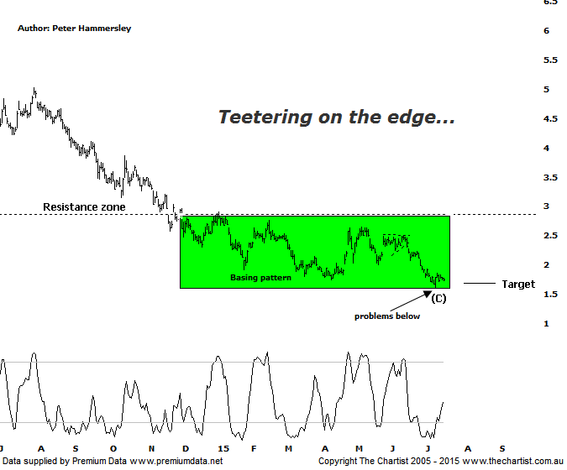

Bottom Line
16/7:
Daily Trend: Down
Weekly Trend: Down
Monthly Trend: Down
Support Levels: $1.61 / $1.16
Resistence Levels: $2.65 - $2.75 / $3.86 / $5.03
Video Analysis
Watch Video Analysis Here
Technical Discussion
Fortescue Metals is an Iron Ore producer and explorer operational in the Pilbara region of Western Australia. It is engaged in mining of iron ore from its Cloudbreak and Christmas Creek mine sites. Its Cloudbreak mine site is located in the Chichester Ranges in the Pilbara region of Western Australia which is 263 kilometres south of Port Headland and 150km north of Newman. Its Christmas Creek is the second mining operation, 50 km to the east of Cloudbreak. The Company has also designed and constructed rail and port facilities to support the development and sale of the Pilbara's stranded iron ore bodies. For the six months ending the 31st of December 2014 revenues decreased 17% to $4.86B. Net income decreased 81% to $331M. Revenues reveal that the average price per unit of iron ore decreased 47% to $66 per metric ton. Broker/Analyst consensus is a comprehensive “Sell”. The dividend yield is 14.2%.
Reasons to be a little optimistic:
→ US$2.3bn of debt has been refinanced at 9.75% with the first payment pushed out to 2019 from 2017.
→ The company could be profitable in FY16 or FY 17.
→ Net debt at the end is FY 14 was US$7.2bn which came in under estimates.
We have been reviewing FMG on a very regular basis over the past few months due to the fact that price has been heading down toward the longer term target as annotated. This target is taken off the weekly time frame (not shown) and is the wave equality projection of a much larger corrective pattern down that commenced in early 2011. In fact the lower target was briefly breached last week though on the positive side of things price did manage to close back above it. The bottom line is that buyers need to step up to the plate at current levels to avoid something even more sinister unfolding. Another positive is that we have some Type-A bullish divergence evident on the weekly chart although it has yet to trigger. If it does trigger a decent bounce could materialise although note the word “bounce” as there is no evidence at this stage that a major leg higher is going to unfold. With iron ore prices continuing to remain under severe pressure FMG simply isn’t going to gain a sustainable head of steam. As mentioned during our last review a basing pattern has been unfolding since the early in the year with the lower boundary of the structure coming under pressure recently. This means it’s even more important that some accumulation starts to materialise around current levels. It could be argued that some bargain hunters have already started to take an interest which is evidenced by the increase in volume which started to show itself a couple of weeks ago. Hopefully this is a trait that will continue. It certainly needs to.
Trading Strategy
It would still be very aggressive to want to be involved here despite the fact that the lower target area is managing to hold. At the moment FMG is at the mercy of the iron ore god’s who haven’t particularly been in good form over the past few years. Should the bullish divergence mentioned above trigger then we’ll be more inclined to suggest initiating partial positions - providing a low risk entry presents itself. However, at this stage price is teetering over the edge of a cliff which is a dangerous position to be in.

