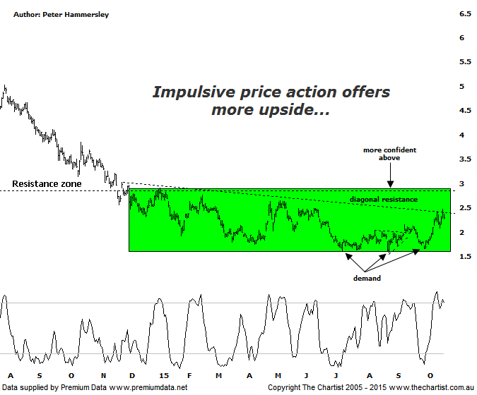
Bottom Line
19/10:
Daily Trend: Up
Weekly Trend: Up
Monthly Trend: Up
Support Levels: $1.58 / $1.16
Resistence Levels: $2.65 - $2.75 / $3.86
Video Analysis
Watch Video Analysis Here
Technical Discussion
Fortescue Metals is an Iron Ore producer and explorer operational in the Pilbara region of Western Australia. It is engaged in mining of iron ore from its Cloudbreak and Christmas Creek mine sites. Its Cloudbreak mine site is located in the Chichester Ranges in the Pilbara region of Western Australia which is 263 kilometres south of Port Headland and 150km north of Newman. Its Christmas Creek is the second mining operation, 50 km to the east of Cloudbreak. The Company has also designed and constructed rail and port facilities to support the development and sale of the Pilbara's stranded iron ore bodies. For the year ending the 30th of June 2015 revenues decreased 27% to $8.57B. Net income decreased 88% to $317M. Revenues reveal the China segment decrease of 29% to $8.05B. Broker/Analyst consensus is a comprehensive “Sell”. The dividend yield is 2.2%.
Reasons to be more optimistic:
→ First quarter production numbers were solid.
→ Cost performance continues to improve.
→ Recent results didn’t reveal anything too sinister.
→ US$2.3bn of debt has been refinanced at 9.75% with the first payment pushed out to 2019 from 2017.
→ The company could be profitable in FY16 or FY 17.
→ Net debt at the end is FY 14 was US$7.2bn which came in under estimates.
Over the past few years any show of resilience by Fortescue has been a cue for disgruntled holders of the stock to offload. Let’s face it, who can blame them with the performance being dire to say the least. However, slightly more positive is the fact that since late 2014 price has meandered sideways which is at least a step in the right direction. It also suggests that accumulation is taking place which could well end in a basing pattern from which to launch from a little further down the track. Also we can see that the bounce over the past few weeks has a more impulsive look about it which is another small positive. A diagonal line of resistance was briefly penetrated on Friday although today there was no follow through whatsoever which would’ve been the ideal situation. We tend to focus more on horizontal resistance as opposed to the diagonal variety although there will be a few traders and investors watching it meaning to some extent it can become a self-fulfilling prophecy. As far as we are concerned though the stock still needs to prove itself technically before getting overly confident that a major low is locked in. The real problem with FMG is that it’s highly leveraged to the price of iron ore which of course isn’t the case with the big boys like BHP & RIO who have diversification as a saving grace. In other words unless iron ore can gain a head of steam it’s highly unlikely that significant progress is going to be witnessed on the chart here.
Trading Strategy
We haven’t been inclined to want to trade FMG over recent times due to a couple of reasons. First of all, price has been extremely choppy and messy with no evidence suggesting that a strong move in either direction is going to transpire. Secondly, we continue to see wild swings which makes it difficult to find a decent low risk entry. If you like the outlook for iron ore you could still buy following a break above Fridays high at $2.47 as it would take price back up through the diagonal line of resistance. Should this transpire price should continue up toward the upper boundary of the basing pattern circa $3.00 though that area would need to be overcome before getting bullish longer term. The formal recommendation is to stand aside.

