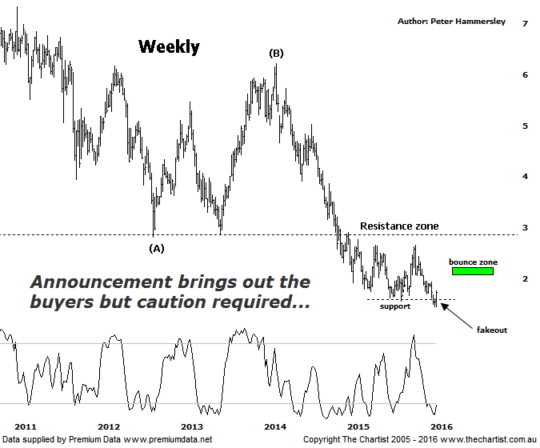

Bottom Line
29/1:
Daily Trend: Up
Weekly Trend: Down
Monthly Trend: Down
Support Levels: $1.44 / $1.16
Resistance Levels: $2.04 - $2.19 / $2.65 - $2.75
Video Analysis
Watch Video Analysis Here
Technical Discussion
Fortescue Metals is an Iron Ore producer and explorer operational in the Pilbara region of Western Australia. It is engaged in mining of iron ore from its Cloudbreak and Christmas Creek mine sites. Its Cloudbreak mine site is located in the Chichester Ranges in the Pilbara region of Western Australia which is 263 kilometres south of Port Headland and 150km north of Newman. Its Christmas Creek is the second mining operation, 50 km to the east of Cloudbreak. The Company has also designed and constructed rail and port facilities to support the development and sale of the Pilbara's stranded iron ore bodies. For the year ending the 30th of June 2015 revenues decreased 27% to $8.57B. Net income decreased 88% to $317M. Revenues reveal the China segment decrease of 29% to $8.05B. Broker/Analyst consensus is a comprehensive “Sell”. The dividend yield is 2.7%.
Reasons to be more optimistic longer term (caution short-term):
→ First quarter production numbers were solid.
→ Cost performance continues to improve.
→ Recent results didn’t reveal anything too sinister.
→ US$2.3bn of debt has been refinanced at 9.75% with the first payment pushed out to 2019 from 2017.
→ The company could be profitable in FY16 or FY 17.
→ Net debt at the end is FY 14 was US$7.2bn which came in under estimates.
Yesterday’s quarterly production report reiterated the fact that the company continues to cut costs which can only be seen as a positive. At the end of the day though FMG is still a one trick pony and no amount of cost-cutting is going to trigger a substantial leg higher if iron ore continues to remain subdued which is exactly what most analysts are predicting - over the next couple of years as a minimum. At the current spot price, some analysts are even confident that the company can make a profit in FY16 though only time will tell. Either way, the market liked yesterday’s announcement with price gaining over 13% today alone; whether the recent show of resilience can continue is the million-dollar question but at least price action over the past couple of days is a small step in the right direction. The problem is that price is still hovering around an old area of support which is now going to be acting as resistance which is just another headwind that the company has to contend with. If traction can continue we’ll be looking for a continuation up toward the typical retracement zone as annotated between $2.04 - $2.19. Even if those higher levels are tagged it wouldn’t move us to a bullish stance medium to longer term. The clue will be in how any rally unfolds and whether it proves to be impulsive or corrective on the way up into the target zone although we’ll revisit that situation if and when those higher levels are approached. We are looking at the weekly timeframe here which also shows another zone of support sitting around $3.00 although we aren’t getting overly enthusiastic in regard to hitting that region at this stage.
Trading Strategy
The problem with spikes like today is that they don’t provide a low risk entry which is a prerequisite before getting involved as far as we are concerned. Yes, there’s a good chance that the target area as annotated is going to be achieved though the risk/reward from current levels isn’t acceptable. However, a short low-volume retracement would gain our interest meaning FMG remains on the short-term watchlist for the more nimble trader. For now though we have to stand aside and remain a little sceptical in regard to the recent bounce.

