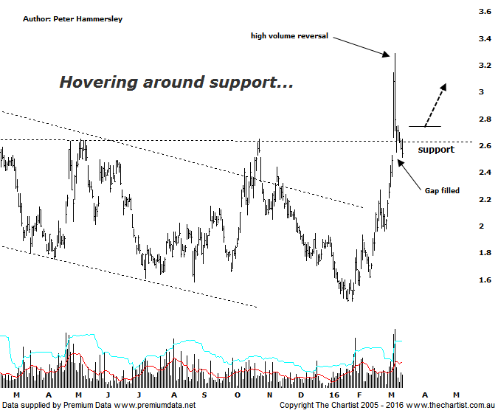

Bottom Line
15/3:
Daily Trend: Neutral
Weekly Trend: Up
Monthly Trend: Up
Support Levels: $1.96 / $1.44 / $1.16
Resistance Levels: $3.29 / $3.98 / $4.51
Video Analysis
Watch Video Analysis Here
Technical Discussion
Fortescue Metals is an Iron Ore producer and explorer operational in the Pilbara region of Western Australia. It is engaged in mining of iron ore from its Cloudbreak and Christmas Creek mine sites. Its Cloudbreak mine site is located in the Chichester Ranges in the Pilbara region of Western Australia which is 263 kilometres south of Port Headland and 150km north of Newman. Its Christmas Creek is the second mining operation, 50 km to the east of Cloudbreak. The Company has also designed and constructed rail and port facilities to support the development and sale of the Pilbara's stranded iron ore bodies. For the six months ending the 31st of December 2015 revenues decreased 31% to $3.34B. Net income decreased 4% to $319M. Revenues reveal the China segment decrease of 31% to $3.19B. Broker/Analyst consensus is “Hold”. The dividend yield is 2.1%.
Reasons to be more optimistic longer term (caution short-term):
→ The reported breakeven price is now US$29/t.
→ First quarter production numbers were solid.
→ Cost performance continues to improve.
→ Recent results didn’t reveal anything too sinister.
→ US$2.3bn of debt has been refinanced at 9.75% with the first payment pushed out to 2019 from 2017.
→ The company could be profitable in FY16 or FY 17.

It’s only a week since our last look at FMG but price action over the past few days means an important juncture has been met. We are going to flip down to the daily chart this evening as this highlights the gap fill that transpired today. In fact, during our last review the ideal situation must come back and fill the gap and clearly reject. We did see a close of the session’s lows today and although a higher close would have been ideal we have to take into account the weakness in the broader market today which didn’t help matters. If we are to see a continuation higher it’s very important that the low of the bar preceding the gap at $2.37 isn’t penetrated - at least from a trading perspective over the short-term. The other big positive is that price is still hovering around an old horizontal line of resistance which ideally will now be acting as support. However, this means there is no room for lower prices here on in with a leg higher needing to kick into gear right here and now. One thing is for sure, volume needs to increase before getting overly confident medium to longer term as it has been quite sedate from early February which is where the recent bounce started to take hold. In fact, the two high-volume bars coincided with recent pivot highs which is a heads up in regard to being a little cautious. Whichever way you look at it we can only view Fortescue as a recovery play although there is excellent upside potential even in regard to seeing a bounce only.
Trading Strategy
This is definitely one for the more aggressive trader only as volatility can be quite high at times which makes placement of the initial stop a little tricky. However, if you want to be involved then buy following a break up through last Thursday’s high at $2.75 with the initial stop placed just beneath the recent pivot low which at this stage is today’s low although this could change over the coming days. The longer term target area is the typical retracement zone sitting between $3.98 - $4.51 which offers a good percentage gain should price get on with the job and trend.

