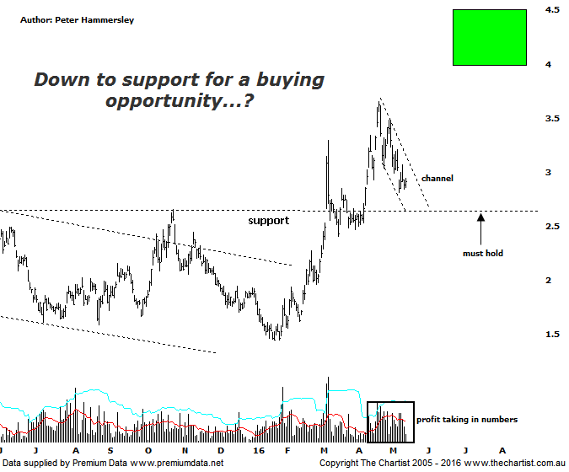

Bottom Line
16/5:
Daily Trend: Down
Weekly Trend: Up
Monthly Trend: Up
Support Levels: $2.40 / $1.96 / $1.44
Resistance Levels: $3.65 / $3.98 / $4.51
Video Analysis
Watch Video Analysis Here
Technical Discussion
Fortescue Metals is an Iron Ore producer and explorer operational in the Pilbara region of Western Australia. It is engaged in mining of iron ore from its Cloudbreak and Christmas Creek mine sites. Its Cloudbreak mine site is located in the Chichester Ranges in the Pilbara region of Western Australia which is 263 kilometres south of Port Headland and 150km north of Newman. Its Christmas Creek is the second mining operation, 50 km to the east of Cloudbreak. The Company has also designed and constructed rail and port facilities to support the development and sale of the Pilbara's stranded iron ore bodies. For the six months ending the 31st of December 2015 revenues decreased 31% to $3.34B. Net income decreased 4% to $319M. Revenues reveal the China segment decrease of 31% to $3.19B. Broker/Analyst consensus is “Sell”. The dividend yield is 1.8%.
Reasons to be more optimistic longer term (caution short-term):
→ The reported breakeven price is now US$29/t.
→ First quarter production numbers were solid.
→ Cost performance continues to improve.
→ Recent results didn’t reveal anything too sinister.
→ US$2.3bn of debt has been refinanced at 9.75% with the first payment pushed out to 2019 from 2017.
→ The company could be profitable in FY16 or FY 17.

We concentrated on the weekly chart back in mid-April which showed that price had failed to break up through a zone of resistance on two occasions with sellers coming out at those slightly higher levels. As such, short-term weakness taking price back beneath $3.00 was anticipated which now appears to be underway. It’s also quite interesting that volume at the recent pivot high increased substantially and has remained elevated during subsequent weakness. It now seems likely that price is going to continue down toward the old line of resistance which should now be acting as support. As long as price doesn’t break beneath the prior pivot low at $2.40 the bullish case medium to longer term remains firmly intact. The small falling channel that’s been unfolding over the past few weeks should be watched carefully as a break through the upper or lower trend lines could well dictate where price heads over the coming months. As we’ve said many times before, FMG is largely a one trick pony and is reliant on the price of iron ore remaining stable. It has been pulling back over more recent times which is exactly the reason why FMG has been correcting. As long as iron ore can avoid rolling over completely there’s no reason why something much more bullish can’t unfold over the coming months and for that matter even years. One thing is for sure, this company has been absolutely smashed over recent years with many analysts and brokers suggesting it was teetering over the edge of a cliff in regard to closing its doors altogether. In the bigger scheme of things, the recent show of resilience hasn’t clawed back a significant portion of the prior leg down but it is a step in the right direction with the stock appearing to be on the road to recovery.
Trading Strategy
“…If price can meander down to the lower boundary of the zone of resistance our interest would increase as it would automatically provide a lower risk entry…” Price hasn’t quite reached our lower target area though it is well on its way to doing so. As suggested last time, signs of strength around the line of support will provide a low risk entry and be reason to jump on following signs of strength. If those lower levels are reached we could look to use our SaR indicator as an entry mechanism although the falling channel also provides a logical entry point. Either way, for the moment FMG is on the watchlist and we may well be putting out a “buy” signal shortly.

