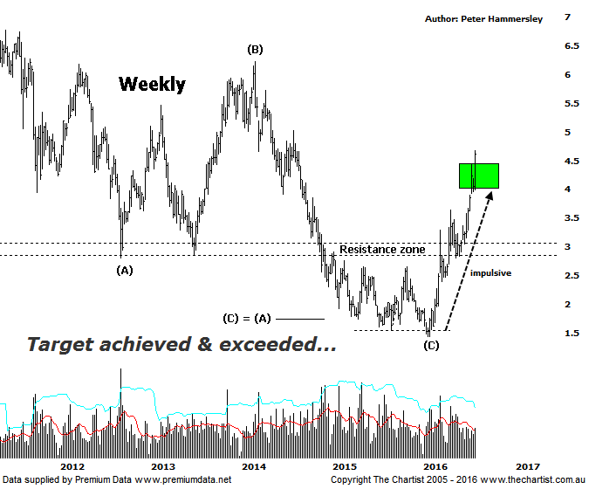

Bottom Line
28/7:
Daily Trend: Up
Weekly Trend: Up
Monthly Trend: Up
Support Levels: $3.65 / $2.40 / $1.96
Resistance Levels: $6.22
Video Analysis
Watch Video Analysis Here
Technical Discussion
Fortescue Metals is an Iron Ore producer and explorer operational in the Pilbara region of Western Australia. It is engaged in mining of iron ore from its Cloudbreak and Christmas Creek mine sites. Its Cloudbreak mine site is located in the Chichester Ranges in the Pilbara region of Western Australia which is 263 kilometres south of Port Headland and 150km north of Newman. Its Christmas Creek is the second mining operation, 50 km to the east of Cloudbreak. The Company has also designed and constructed rail and port facilities to support the development and sale of the Pilbara's stranded iron ore bodies. For the six months ending the 31st of December 2015 revenues decreased 31% to $3.34B. Net income decreased 4% to $319M. Revenues reveal the China segment decrease of 31% to $3.19B. Broker/Analyst consensus is “Sell”. The dividend yield is 1.2%.
Reasons to be more optimistic longer term (caution short-term):
→ The reported breakeven price is now US$29/t.
→ First quarter production numbers were solid.
→ Cost performance continues to improve.
→ Recent results didn’t reveal anything too sinister.
→ US$2.3bn of debt has been refinanced at 9.75% with the first payment pushed out to 2019 from 2017.
→ The company could be profitable in FY16 or FY 17.

Impulsive price action was taking hold during our last review with the highest expectation being to head up into the typical retracement zone of the whole prior leg down off the February 2014 highs. This has now been achieved although the interesting aspect of the chart is that a corrective pattern higher hasn’t unfolded. This is what’s keeping the door open for even higher levels to be attained further down the track. Indeed, we can now look to the typical retracement zone of the whole leg down from the all-time highs made in 2008 sitting between $7.30 – $8.67 although this is the longer term target zone and isn’t going to be achieved overnight. The stabilization in the price of iron Ore has undoubtedly been helping sentiment although it’s also worth noting that the company has made several positive announcements over the past few months which has definitely been providing a helping hand. The stock has turned around fundamentally although a short pause for breath wouldn’t go amiss. With this in mind, we do have some bearish divergence in position on the daily chart (not shown) with price making a higher high whilst our indicator has failed to confirm by making a lower high. It’s nice deep “V” as well which adds weight to the significance of the pattern. Should this trigger then our wanted consolidation or short retracement could well unfold. We’ll be keeping an eye on our oscillator over the coming days as in this instance, it could provide another entry point should it prove to be significant. For now though, the trend is strong and we have to simply go with the flow and expect high prices.
Trading Strategy
The quarterly production report released yesterday was the trigger for around an 8% climb which has been followed today by another 5% surge. This isn’t unusual for this stock as it can be extremely volatile at times both to the up, and to the downside. This always makes it difficult to find an opportunity to jump on, especially when using tight protective stops which is always our aim. That said, should a small micro consolidation pattern or similar materialise on the back of the bearish divergence mentioned above, FMG will find its way into the Position Status Page. For now, we don't want to be chasing it higher though.

