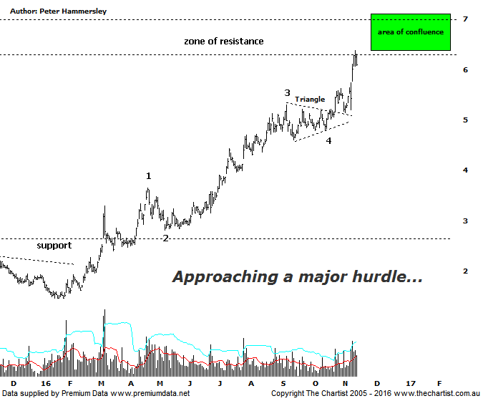

Bottom Line
15/11:
Daily Trend: Up
Weekly Trend: Up
Monthly Trend: Up
Support Levels: $4.61 / $3.96 - $3.56
Resistance Levels: $7.01 - $7.15 / $8.57
Video Analysis
Watch Video Analysis Here
Technical Discussion
Fortescue Metals is an Iron Ore producer and explorer operational in the Pilbara region of Western Australia. It is engaged in mining of iron ore from its Cloudbreak and Christmas Creek mine sites. Its Cloudbreak mine site is located in the Chichester Ranges in the Pilbara region of Western Australia which is 263 kilometres south of Port Headland and 150km north of Newman. Its Christmas Creek is the second mining operation, 50 km to the east of Cloudbreak. The Company has also designed and constructed rail and port facilities to support the development and sale of the Pilbara's stranded iron ore bodies. For the year ending the 30th of June 2016 revenues decreased 17% to $7.08B. Net income increased from $317M to $984M. Revenues reflect the China section decrease of 16% to $6.79B. Broker/Analyst consensus is a comprehensive “Sell”. The dividend yield is 2.4%.
Reasons to be more optimistic longer term:
→ Debt repayment has gained traction.
→ Cost reduction continues to improve.
→ Spot iron ore prices remain resilient.
→ Commodity price forecasts have generally been revised higher by brokers and analysts.
→ Pilbara has morphed into a world-class low-cost business.
We noted last time that a couple of brokers had turned slightly more bullish although overall they remain unconvinced. If someone were to be cynical, they could say that eventually brokers will be correct in their assessment that the company is overbought although for the moment price continues to power higher. The increase in the price of iron ore has been the stimulus required for recent strength although having said that, Management have been proactive in strengthening the company fundamentally. During our last look at the stock price was consolidating within a symmetrical triangle which usually results in a break in the direction of the prior trend which in this instance is obviously up. In that regard, we couldn’t have asked for too much more with impulsive price action kicking into gear almost immediately. The patterns are now at a very important juncture though with price a couple of days ago heading into the zone of resistance which goes all the way back to early 2011. There is also a large area of confluence around current levels, and slightly higher which needs to be watched carefully as it could prove to be a reversal zone. The typical retracement zone of the whole leg down off the 2008 highs aligns with the zone of resistance, as does the wave equality projection. Elliott Wave theory shows that normally waves-1 and-3 are the same length which in this instance provides a target at $7.01. As a rule of thumb, the more confluence there is, the greater the chance that there is going to be a reaction which is what we must be on alert for here. The other interesting pattern is showing on the weekly chart (not shown) with Type-A bearish divergence in place although it’s yet to trigger. Again, something to keep a close eye on over the coming days.
Trading Strategy
We are currently holding long positions in MGX meaning we do have exposure to iron ore. Having said that, there is no low-risk opportunity here and if our analysis proves to be correct then a retracement should be just around the corner. A comprehensive break up through $7.00 would be extremely bullish though it would be less than ideal from a pure pattern perspective. We retain our bullish stance longer term though a decent pause for breath wouldn’t go amiss before the trend continues.

