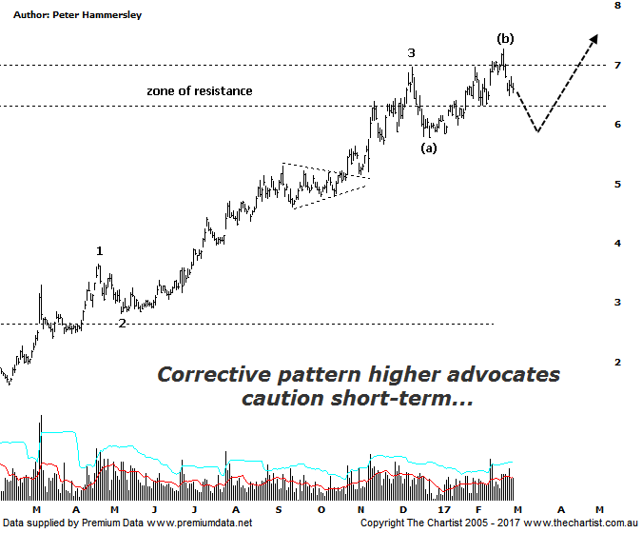

Bottom Line
1/3:
Daily Trend: Down
Weekly Trend: Up
Monthly Trend: Up
Support Levels: $5.15 - $4.61 / $3.96 - $3.56
Resistance Levels: $7.01 - $7.27 / $8.57
Video Analysis
Watch Video Analysis Here
Technical Discussion
Fortescue Metals is an Iron Ore producer and explorer operational in the Pilbara region of Western Australia. It is engaged in mining of iron ore from its Cloudbreak and Christmas Creek mine sites. Its Cloudbreak mine site is located in the Chichester Ranges in the Pilbara region of Western Australia which is 263 kilometres south of Port Headland and 150km north of Newman. Its Christmas Creek is the second mining operation, 50 km to the east of Cloudbreak. The Company has also designed and constructed rail and port facilities to support the development and sale of the Pilbara's stranded iron ore bodies. For the six months ending the 31st of December 2016 revenues increased 34% to $4.49B. Net income increased from $319M to $1.22B. Revenues reflect the China section increase of 35% to $4.31B. Broker/Analyst consensus is a comprehensive “Sell”. The dividend yield is 2.2%.
Reasons to be more optimistic longer term (caution short-term):
→ Improving balance sheet provides scope to increase the dividend.
→ Dividend payout ratio lifted to almost 40%.
→ Debt repayment has gained traction.
→ Cost reduction continues to improve.
→ Spot iron ore prices remain resilient.
→ Commodity price forecasts have generally been revised higher by brokers and analysts.
→ Pilbara has morphed into a world-class low-cost business.
A push above the upper boundary of the zone of resistance would normally be a bullish proposition, and we said as much during our last review. However, the telling factor here is how the recent rally has unfolded. It’s been choppy and messy in nature suggesting it’s part of a larger corrective pattern. In fact, looking at the price action over the past few months emphasises the stark difference. Until recently clean strong trends have been unfolding. Not that this change moves us to a bearish stance medium to longer term as it certainly doesn’t. The mere fact that the recent pivot high has been overcome increases the chances that the alternate count is going to win the day. It also decreases the probability of getting the deeper retracement which would result in a substantial percentage loss from current levels. Running with the theme of the alternate count shows that the recent pivot high completes intermediate degree wave-(b) meaning the current leg South needs to travel to lower levels, at least down to around $6.00 and potentially slightly beneath. This would complete a larger flat pattern which would be ideal regarding a completed wave-4. The stage will then be set for the strong prior uptrend to kick back into gear with a vengeance. Advocating caution is also bearish divergence evident on the weekly chart (not shown). It’s also triggered which increases its significance. It could well be that last week’s high is going to remain untouched until our oscillator unwinds fully on the larger timeframe.
Trading Strategy
The choppy nature of the recent rally advocates caution which in itself means there’s no reason to be looking for a buying opportunity at this stage, especially with the bearish divergence also providing a headwind. However, should the flat pattern into wave-4 form over the coming weeks our interest will be rekindled. We’ll keep Fortescue on the watchlist as it’s undoubtedly an exceptionally strong trending stock; now isn’t the time to be involved though.

