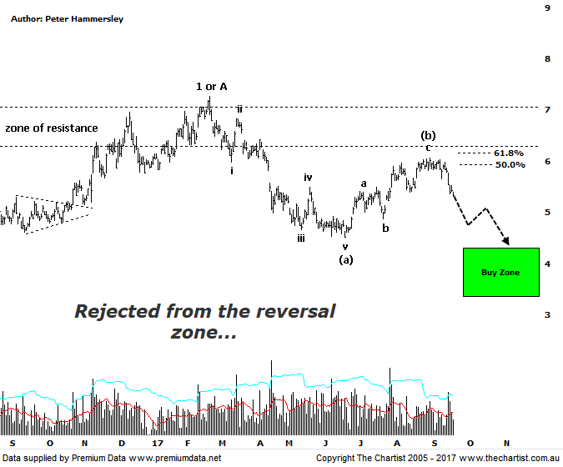

Bottom Line
20/9:
Daily Trend: Down
Weekly Trend: Down
Monthly Trend: Down
Support Levels: $4.52 - $4.35 / $3.66 / $1.44
Resistance Levels: $6.07 - $6.22 / $7.01 - $7.27 / $8.57
Video Analysis
Watch Video Analysis Here
Technical Discussion
Fortescue Metals is an Iron Ore producer and explorer operational in the Pilbara region of Western Australia. It is engaged in mining of iron ore from its Cloudbreak and Christmas Creek mine sites. Its Cloudbreak mine site is located in the Chichester Ranges in the Pilbara region of Western Australia which is 263 kilometres south of Port Headland and 150km north of Newman. Its Christmas Creek is the second mining operation, 50 km to the east of Cloudbreak. The Company has also designed and constructed rail and port facilities to support the development and sale of the Pilbara's stranded iron ore bodies. For the year ending the 30th of June 2017 revenues increased 19% to $8.45B. Net income increased from $984M to $2.09B. Revenues highlight the China section increase of 18% to $8B and the Iron Ore increase of 18% to $53 per metric ton. Net income benefited from the net foreign exchange gain which increased from $0K to $13M. Broker/Analyst consensus is “Hold”. The dividend yield is 8.0%.
Reasons to be more optimistic longer term (downside short-term):
→ Dividend increase to a 67% payout for the first half.
→ Costs continue to fall.
→ A 50%-80% pay-out of net profit, increasing from the previous 30% - 40%.
→ A successful unsecured notes offering will be used to pay off the 2019 term loan and 2022 unsecured note.
→ Improving balance sheet provides scope to increase the dividend.
→ Debt repayment has gained traction.
→ Cost reduction continues to improve.
→ Commodity price forecasts have generally been revised higher by brokers and analysts.
→ Pilbara has morphed into a world-class low-cost business.
Price was bouncing nicely during our last review although the patterns suggested an interim top was either in place or was about to be made. The reason being, a strong impulsive leg down from the February 2017 highs had been followed by a choppy recovery which had already tagged the 50% - 61.8% retracement zone. Marginally higher prices have been made although the upper boundary of the typical retracement zone hasn’t been overcome which is important. Right on cue, sellers have stepped up and although it’s still early days it’s been a significant sell-off over the past week or so. From an Elliott stance, there’s every reason to suggest that wave-(b) is in place with the final probe down within wave-(c) likely underway. Interestingly, the typical retracement zone of the larger pattern sitting around $4.00 came within a whisker of being tagged during the initial thrust lower which suggests that the lower boundary of the target area just above $3.00 is going to be the next port of call. This would provide much more symmetry. We must also consider that the 61.8% retracement level of the whole leg higher to wave-1 or-A shows good confluence with the wave equality projection which is making up the lower boundary of the target at $3.32. It would take an immediate push back up through the recent pivot high and the 61.8% retracement level at $6.22 before thinking in terms of avoiding the deeper retracement. However, even if that make or break point is overcome it wouldn’t imply the longer-term uptrend is going to reignite. It’s more likely that a larger consolidation pattern would need to unfold as opposed to a multi-year trend higher kicking in.
Trading Strategy
There is scope to short-sell at current levels although at this stage the initial stop would need to be placed just above the high of wave-(b) at $6.08. As mentioned above, we’d expect the lower boundary of the target area to be tagged which is where profits should be banked if offered. I’m not going to make a formal recommendation here although a lacklustre bounce or even a micro consolidation pattern could see FMG make it into the position status page. Longer term traders and investors looking for a buying opportunity need to wait for the correction to run its course which should take several weeks as a minimum.

