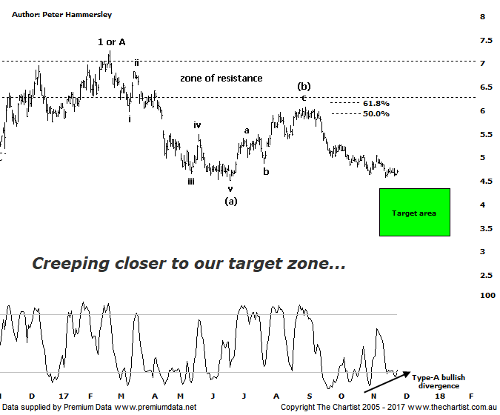

Bottom Line
27/11:
Daily Trend: Neutral
Weekly Trend: Down
Monthly Trend: Down
Support Levels: $4.52 - $4.35 / $3.66 - $3.32
Resistance Levels: $6.07 - $6.22 / $7.01 - $7.27 / $8.57
Video Analysis
Watch Video Analysis Here
Technical Discussion
Fortescue Metals is an Iron Ore producer and explorer operational in the Pilbara region of Western Australia. It is engaged in mining of iron ore from its Cloudbreak and Christmas Creek mine sites. Its Cloudbreak mine site is located in the Chichester Ranges in the Pilbara region of Western Australia which is 263 kilometres south of Port Headland and 150km north of Newman. Its Christmas Creek is the second mining operation, 50 km to the east of Cloudbreak. The Company has also designed and constructed rail and port facilities to support the development and sale of the Pilbara's stranded iron ore bodies. For the year ending the 30th of June 2017 revenues increased 19% to $8.45B. Net income increased from $984M to $2.09B. Revenues highlight the China section increase of 18% to $8B and the Iron Ore increase of 18% to $53 per metric ton. Net income benefited from the net foreign exchange gain which increased from $0K to $13M. Broker/Analyst consensus is “Hold”. The dividend yield is 9.8%.
Reasons to be more optimistic longer term (downside short-term):
→ Dividend increase to a 67% payout for the first half.
→ Costs continue to fall.
→ A 50%-80% pay-out of net profit, increasing from the previous 30% - 40%.
→ A successful unsecured notes offering will be used to pay off the 2019 term loan and 2022 unsecured note.
→ Improving balance sheet provides scope to increase the dividend.
→ Debt repayment has gained traction.
→ Cost reduction continues to improve.
→ Commodity price forecasts have generally been revised higher by brokers and analysts.
→ Pilbara has morphed into a world-class low-cost business.
Over the past few reviews the risk has been to the downside for FMG, and our expectation of lower prices remains firm. The leg down over the past few weeks now has our target zone within touching distance meaning we need to be on alert for buyers returning over the coming weeks and months. However, we also need to be cognizant that there is confluence around the lower boundary of the target zone which comprises the wave equality projection and the 61.8% retracement level. That’s not to say a deeper retracement is guaranteed although it must be our expectation when taking into account what the patterns are signifying. One of the problems fundamentally for the company has been sentiment which has taken a turn for the worse. The view by many analysts is that the 58% iron index discount will never come down from its current 30% level. Let’s also not forget that the CEO is new which always brings uncertainty. That said, brokers this month have become a little more bullish on the stock with three putting out “outperform” or “accumulate” recommendations. This aligns more with our thoughts over the medium to longer term although we remain sceptical over the short-term. Price is now hovering around a minor area of support which could mean a few buyers are currently waiting in the wings for a buying opportunity. A push beneath the pivot low at $4.52 in a move that sticks would open the door for our wanted deeper retracement to unfold. A quick look at the weekly chart (not shown) shows that current weakness is nothing out of the ordinary from an Elliott Wave point of view. Indeed, wave-(c) should now be in motion meaning a conclusion to the recent leg South shouldn’t be too far away.
Trading Strategy
“…If you want full exposure to iron ore then FMG is the one to watch over the coming weeks. That said, if our wave count is correct then a buying opportunity is likely going to present itself around the $3.65 - $3.30 area so patience is still required…” Our view remains unchanged which means our buying opportunity is moving ever closer. It’s still too early to take the plunge but it shouldn’t be too long before we are on the lookout for buyers in our potential reversal zone. If you want exposure to the sector, and especially iron ore then Fortescue needs watching which is exactly what we’ll be doing.

