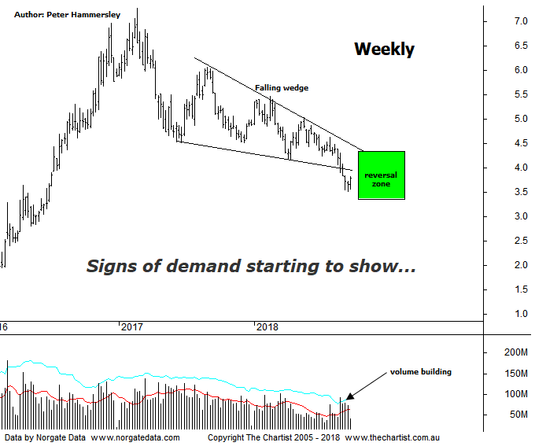

Bottom Line
19/9:
Daily Trend: Up
Weekly Trend: Down
Monthly Trend: Down
Support Levels: $3.66 - $3.32
Resistance Levels: $4.25 - $4.17 / $5.46 / $6.07 - $6.22
Video Analysis
Watch Video Analysis Here
Technical Discussion
Fortescue Metals is an Iron Ore producer and explorer operational in the Pilbara region of Western Australia. It is engaged in mining of iron ore from its Cloudbreak and Christmas Creek mine sites. Its Cloudbreak mine site is located in the Chichester Ranges in the Pilbara region of Western Australia which is 263 kilometres south of Port Headland and 150km north of Newman. Its Christmas Creek is the second mining operation, 50 km to the east of Cloudbreak. The Company has also designed and constructed rail and port facilities to support the development and sale of the Pilbara's stranded iron ore bodies. For the year ending the 30th of June 2018 revenues decreased 18% to $6.89B. Net income decreased 58% to $879M. Revenues highlight the China section decrease of 22% to $6.21B and Iron Ore which decreased 17% to $44 per metric ton. Net income also highlights a loss on early debt redemption which increased from $59M to $289M. Broker/Analyst consensus is “Hold”. The dividend yield is 6.6%.
Reasons to be more optimistic longer term:
→ Improved grades flowing from the new Eliwana project should lift pricing against the benchmark.
→ Increased product specifications for the West Pilbara finds feasible.
→ Management appear committed to a steady dividend.
→ Costs continue to fall.
→ A successful unsecured notes offering will be used to pay off the 2019 term loan and 2022 unsecured note.
→ Debt repayment has gained traction.
→ Cost reduction continues to improve.
→ Commodity price forecasts have generally been revised higher by brokers and analysts.
→ Pilbara has morphed into a world-class low-cost business.
The mining sector has been stagnating recently although a positive lead from US markets overnight on the back of the Chinese tariff decision, coupled with higher metals prices has helped sentiment. Copper was up almost 2.5% with iron ore also enjoying a much better session. Whether there is going to be any follow-through only time will tell but at least it’s a step in the right direction. One thing is for sure, FMG had a much better day with price gaining around 4% at close. We are going to look at the daily timeframe during tonight’s video although the better patterns are showing on this weekly chart. We’ve been watching a falling wedge, also known as an Ending diagonal triangle since June, which are strong reversal patterns. The lower boundary of the pattern has been overcome although this is perfectly acceptable and is known as a Throwover. However, there is little room for lower prices, with the lower boundary of our reversal zone coming close to being tagged recently. The bottom line is, today’s strength needs to follow through if something more bullish is about to unfold. On this larger timeframe the upper boundary of the wedge will need to be overcome before the pattern triggers although the smaller degree patterns on the daily chart should give us a heads up regarding which direction the next major move is going to take. The other interesting aspect of the chart is the volume which has started to increase over the past few weeks. It’s not excessively high at this juncture although it’s trending in the right direction which adds weight to a more bullish outcome.
Trading Strategy
If you want to take a more aggressive stance you could accumulate partial positions in this region and place the protective stop just beneath our target area at $3.30. You can always top up once the upper boundary of the wedge slightly above $4.00 is overcome. There is no formal recommendation at this juncture as we require further confirmation that a low is locked in, especially as it’s still early days regarding the recent turnaround. One for the short-term watchlist so don’t be surprised to see it in the position status page shortly.

