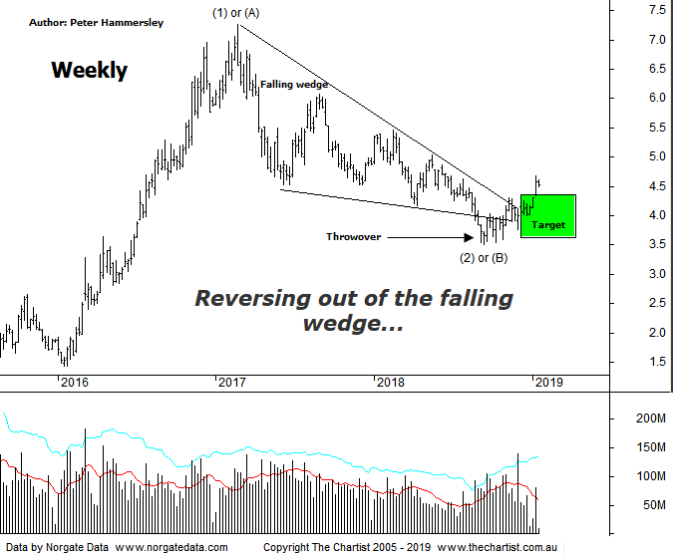

Bottom Line
14/1:
Daily Trend: Up
Weekly Trend: Up
Monthly Trend: Up
Support Levels: $4.30 - $4.20 / $3.51 - $3.32
Resistance Levels: $5.46 / $6.07 - $6.22
Video Analysis
Watch Video Analysis Here
Technical Discussion
Fortescue Metals is an Iron Ore producer and explorer operational in the Pilbara region of Western Australia. It is engaged in mining of iron ore from its Cloudbreak and Christmas Creek mine sites. Its Cloudbreak mine site is located in the Chichester Ranges in the Pilbara region of Western Australia which is 263 kilometres south of Port Headland and 150km north of Newman. Its Christmas Creek is the second mining operation, 50 km to the east of Cloudbreak. The Company has also designed and constructed rail and port facilities to support the development and sale of the Pilbara's stranded iron ore bodies. For the year ending the 30th of June 2018 revenues decreased 18% to $6.89B. Net income decreased 58% to $879M. Revenues highlight the China section decrease of 22% to $6.21B and Iron Ore which decreased 17% to $44 per metric ton. Net income also highlights a loss on early debt redemption which increased from $59M to $289M. Broker/Analyst consensus is “Hold”. The dividend yield is 5.2%.
Reasons to be more optimistic longer term:
→ Improved grades flowing from the new Eliwana project should lift pricing against the benchmark.
→ Increased product specifications for the West Pilbara finds feasible.
→ Management appear committed to a steady dividend.
→ Costs continue to fall.
→ A successful unsecured notes offering will be used to pay off the 2019 term loan and 2022 unsecured note.
→ Debt repayment has gained traction.
→ Cost reduction continues to improve.
→ Commodity price forecasts have generally been revised higher by brokers and analysts.
→ Pilbara has morphed into a world-class low-cost business.
We’ve been focusing on the weekly chart recently simply because it shows the clearer patterns. We’ll stick with the larger timeframe this evening although it’s worth watching the video this evening as we delve into the daily chart as well. The headline pattern here remains the falling wedge which are also known as Ending diagonal triangles. As I’ve said many times before I believe they are one of the strongest reversal patterns available to us. More often than not we’ll also see a “Throwover” which means price will break down through the lower trend line of the pattern before heading higher which is what transpired here. Also note that price has hit the typical retracement zone which provided some confluence with the falling wedge. The more confluence we have, the greater the chance it’s going to prove to be significant which in this instance should mean FMG continuing higher. Usually price will head to the origin of the pattern which in this instance aligns with $7.00, offering plenty of upside potential. Trading off weekly charts isn’t overly popular although the beauty is that these larger patterns usually offer higher target areas which is true here. Adding weight to the more bullish case is the large increase in volume at recent lows suggesting some of the smart money was starting to take an interest. As long as the price of iron ore can hold itself together there’s no reason why Fortescue can’t continue to rally. The prerequisite to a decent trend unfolding is impulsive price action higher here on in, with anything other being reason to be cautious. On the daily chart (not shown) this has started to kick in. Price has also just pushed up through a minor line of resistance which should now be acting as support around $4.20. The patterns look good on both the daily and weekly charts so let’s see if some decent gains can be made.
Trading Strategy
As alluded to above, a small pull-back is underway on the daily chart meaning a low risk entry could soon be available. Just be aware that there is the potential to come back down to fill the gap, and even tag support before the trend kicks back into gear. However, a gap fill followed by clear rejection would also offer a buying opportunity. There is no formal recommendation but it’s one for the watchlist if you want exposure to the sector and iron ore.

