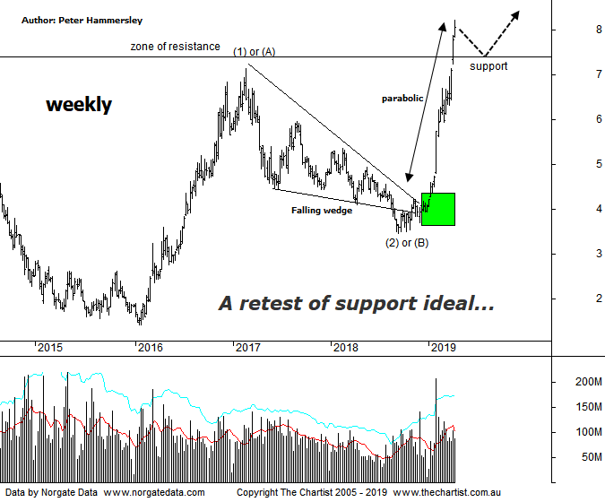

Bottom Line
12/4:
Daily Trend: Up
Weekly Trend: Up
Monthly Trend: Up
Support Levels: $7.14 / $3.51 - $3.32
Resistance Levels: $9.30 / $12.92 (All-time high)
Video Analysis
Watch Video Analysis Here
Technical Discussion
Fortescue Metals is an Iron Ore producer and explorer operational in the Pilbara region of Western Australia. It is engaged in mining of iron ore from its Cloudbreak and Christmas Creek mine sites. Its Cloudbreak mine site is located in the Chichester Ranges in the Pilbara region of Western Australia which is 263 kilometres south of Port Headland and 150km north of Newman. Its Christmas Creek is the second mining operation, 50 km to the east of Cloudbreak. The Company has also designed and constructed rail and port facilities to support the development and sale of the Pilbara's stranded iron ore bodies. For the six months ending the 31st of December 2018 revenues decreased 4% to $3.54B. Net income decreased 5% to $644M. Revenues highlight the sale of iron ore which decreased 23% to $2.8B whilst other revenue decreased to $1M. Broker/Analyst consensus is “Hold”. The dividend yield is 2.9%.
Reasons to be more optimistic longer term:
→ A rate of return of around 16% from the Iron Bridge magnetite project possible.
→ The majority of Fortescue’s metals product grade to over 60%.
→ Blending of the high-grade magnetite product could uptrend the company’s overall realised price.
→ The spike in the iron ore price is a big step in the right direction.
→ Improved grades flowing from the new Eliwana project should lift pricing against the benchmark.
→ Increased product specifications for the West Pilbara finds feasible.
→ A successful unsecured notes offering will be used to pay off the 2019 term loan and 2022 unsecured note.
→ Commodity price forecasts have generally been revised higher by brokers and analysts.
→ Pilbara has morphed into a world-class low-cost business.
It’s been well over a month since our last look at FMG which may seem strange considering the potency of the trend. However, not too much has changed from our last review, where parabolic price action was already underway. There’s hardly been a blip over the past few weeks with the strong trend continuing. The only real difference is that price was sitting beneath a zone of resistance last time which has now been overcome meaning it should now be acting as support during any subsequent weakness. Since September of last year price has risen by more than 138% which is significant within a short period of time. However, as we’ve noted many times before, when price breaks through the upper boundary of a falling wedge or Ending diagonal triangle it will normally hit the origin of the pattern in around one 3rd to half of the time taken by the pattern itself which is a box that can be ticked here. In fact, that target has now been overcome although this wasn’t unexpected, especially when considering the wave count. This weekly chart shows wave-(3) or-(C) should be taking price up toward the wave equality projection circa $9.30 as a minimum. If a more bullish 5-wave move is unfolding, then the 1.618 projection up near $13.00 should be the next port of call although this is obviously a much longer-term target area. The ideal situation is to consolidate around the new zone of support or come back to retest it following short-term strength. As long as buyers step back up around the zone of support price should continue to head north.
Trading Strategy
“…Straight-line moves are all well and good if you are already aboard although they don’t provide a low risk entry. With the target area almost achieved we have no option but to continue to stand aside…” The straight-line move higher has continued although with the line of resistance overcome an opportunity could be forthcoming shortly. As mentioned above, we need to see FMG come back to retest the breakout area or at least consolidate to provide a low risk entry. Until this transpires we’ll continue to remain patient. one for the watchlist.

