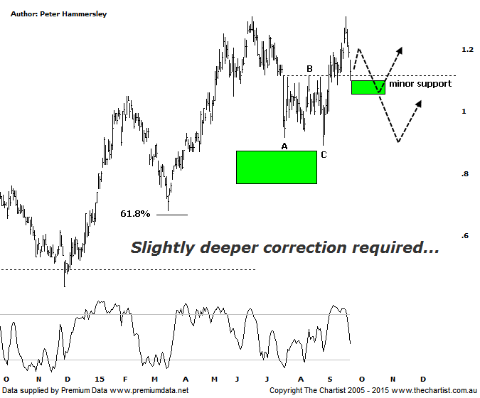

Bottom Line
23/9:
Daily Trend: Neutral
Weekly Trend: Up
Monthly Trend: Up
Support levels: $1.09 - $1.05 / $0.89 - $0.87 / $0.76
Resistance levels: $1.305
Video Analysis
Watch Video Analysis Here
Technical Discussion
Evolution Mining owns 5 gold and silver mines in Queensland and Western Australia and retains a 100% interest in all of them. The company was formed in October 2011 via a merger between Catalpha Resources and Conquest Mining. Recent results were lower than most brokers and analysts forecasts though it has turned the corner in being cash flow positive this year. The company’s full year production guidance of between 400 – 450,000 ounces of gold should be attainable. Dividend yield is 1.73%.
Reasons to be optimistic longer term:
→ Gold hedging is in position which secures strong margins for a part of production, adding cash-flow security.
→ The Cowal acquisition should increase earnings and cash flow.
→ The recent acquisition of La Mancha increases scale.
→ Financing terms have been renegotiated for the better.
→ Five equally sized Gold mines provide reliable production figures.
→ There is potential to prolong mine life from the existing 4.7 years.
→ It’s highly leveraged to a rising Gold price in A$.
It’s only a couple of weeks since our last look at EVN where we were looking for price to come back and retest the minor line of support before heading higher. That’s exactly what transpired today meaning it’s a logical time to revisit the patterns. The A-B-C correction is still firmly in position which offers plenty of upside. However, whether price is ready to head higher immediately or in a few weeks’ time is open to debate. The clue will be in how price hits the typical retracement zone as annotated between $1.10 - $1.05. The retracement over the past few days has almost been parabolic in nature and if today’s low is overcome immediately then a little more time is going to be required before our wanted leg higher kicks in. A straight line decline into the 50% - 61.8% zone should not complete the whole corrective pattern, so should this transpire then a retest of the low of wave-C around $0.89 is likely going to take place. This would complete a larger flat pattern and provide much more symmetry from a time perspective. That said, we had a similar pattern in SBM a few weeks ago where we were also looking for one final probe down to present a buying opportunity. That particular stock took off immediately and hasn’t looked back meaning we have to be cognizant of a similar thing happening here. A lacklustre bounce over the coming days followed by a probe down to the lower boundary of the target would add plenty of weight behind the case for higher prices without getting the deeper retracement.
Trading Strategy
We are still keen on Gold stocks though that doesn’t automatically mean we go out and buy with our ears pinned back. As mentioned above, we missed the recent surge higher in SBM and we don’t want to be sitting at the station if a similar thing occurs here. That said, there’s no need to rush in and initiate positions right here and now with a little more patience required. Let’s see how the smaller degree patterns develop as they’ll give us a big clue as to whether the buying opportunity is going to present itself around current levels or slightly deeper circa $0.90. Firmly on the watch list.

