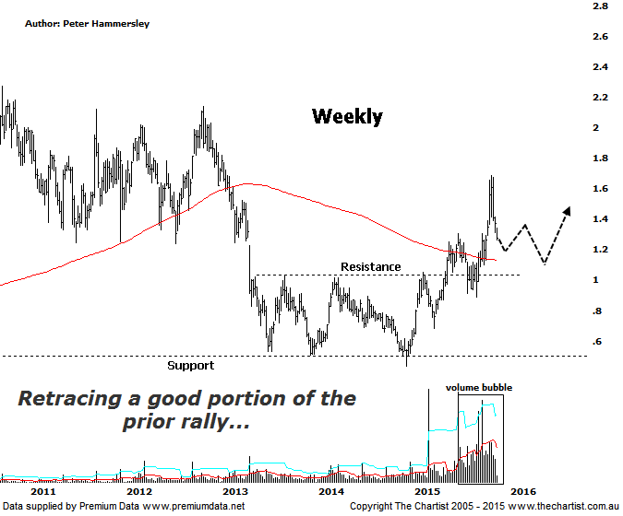
Bottom Line
9/11:
Daily Trend: Down
Weekly Trend: Up
Monthly Trend: Up
Support levels: $1.26 / $1.00
Resistance levels: $1.685 / $2.14 - $2.27
Video Analysis
Watch Video Analysis Here
Technical Discussion
Evolution Mining owns 5 gold and silver mines in Queensland and Western Australia and retains a 100% interest in all of them. The company was formed in October 2011 via a merger between Catalpha Resources and Conquest Mining. Recent results were lower than most brokers and analysts forecasts though it has turned the corner in being cash flow positive this year. The company’s full year production guidance of between 400 – 450,000 ounces of gold should be attainable. Dividend yield is 1.73%.
Reasons to be optimistic longer term:
→ Gold hedging is in position which secures strong margins for a part of production, adding cash-flow security.
→ The Cowal acquisition should increase earnings and cash flow.
→ The recent acquisition of La Mancha increases scale.
→ Financing terms have been renegotiated for the better.
→ Five equally sized Gold mines provide reliable production figures.
→ There is potential to prolong mine life from the existing 4.7 years.
→ It’s highly leveraged to a rising Gold price in A$.
There were a couple of things to keep a close eye on during our last look at EVN with the first being a gap that had been left. Secondly, there was also bearish divergence in position although at that stage it hadn’t triggered. As it turns out the bearish divergence proved to be significant with price reversing lower almost immediately. The one thing we can’t ignore is the turnaround in the price of gold itself, with all gold Miners suffering as a consequence. Having said that, the likes of EVN shown here and SBM have been rocketing higher with a serious degree of attitude over the past few months which puts the recent pull-back into perspective. I won’t go into the reasons for the decline in the yellow metal itself as we took a look at this in Thursday’s review of the Gold Sub Sector (XGD). One thing’s for sure though, if gold continues its decline the door is open for Evolution to head back down to old resistance/new support. I’m going to go back to the weekly time frame this evening as it clearly demonstrates that lower prices are not only likely, but also healthy when looking at the larger degree patterns. It’s also worth noting that the movement south over the past three weeks has been impulsive in nature meaning a larger 3-leg corrective pattern down is more than feasible. Should this be correct we are only in the first stage of a 3-wave counter trend movement.
Trading Strategy
Although the sector and EVN are looking a little oversold over the short-term there is no reason to be looking for a buying opportunity quite yet. Yes, a bounce could ensue pretty much immediately although I wouldn’t be looking to trade it as upside is looking limited at this stage. Should our wanted 3-wave correction take hold we’ll be on the lookout for a chance to jump on nearer the line of support as annotated. As we are looking at the larger degree patterns here, any subsequent correction is likely going to take weeks as opposed to days meaning some patience is going to be required.

