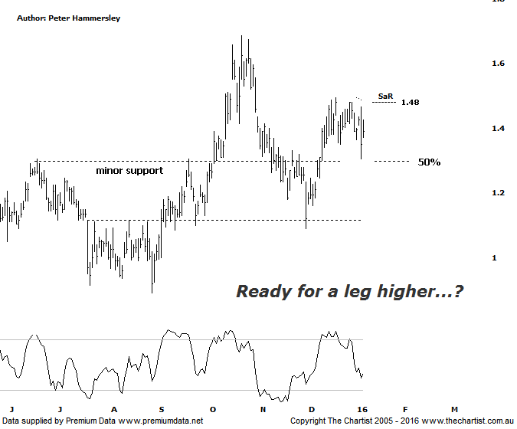

Bottom Line
7/1:
Daily Trend: Down
Weekly Trend: Neutral
Monthly Trend: Up
Support levels: $1.29 - $1.24 / $1.09
Resistance levels: $1.495 / $1.685 / $2.14 - $2.27
Video Analysis
Watch Video Analysis Here
Technical Discussion
Evolution Mining owns 5 gold and silver mines in Queensland and Western Australia and retains a 100% interest in all of them. The company was formed in October 2011 via a merger between Catalpha Resources and Conquest Mining. Recent results were lower than most brokers and analyst’s forecasts though it has turned the corner in being cash flow positive this year. The company’s full year production guidance of between 400 – 450,000 ounces of gold should be attainable. Dividend yield is 1.4%.
Reasons to be optimistic longer term:
→ Gold hedging is in position which secures strong margins for a part of production, adding cash-flow security.
→ The Cowal acquisition should increase earnings and cash flow.
→ The recent acquisition of La Mancha increases scale.
→ Financing terms have been renegotiated for the better.
→ Five equally sized Gold mines provide reliable production figures.
→ There is potential to prolong mine life from the existing 4.7 years.
→ It’s highly leveraged to a rising Gold price in A$.
There was upside potential following our last look at EVN with a push up into the typical retracement zone the ideal situation. This has been the way forward though the interesting thing here is that it was a straight line movement higher into the target area. In fact the upper boundary of the target has been overcome by a small margin which also increases the chances that something more bullish is going to unfold. From the high made on the 17th of December last year a clear 3-leg corrective pattern has taken price down to the 50% retracement level as annotated which is a common occurrence. Even if a corrective pattern higher is unfolding we’d expect the wave equality projection up around $1.71 to be tagged which aligns almost exactly with the previous highs made back in October of last year. Should the more bullish case prove to be the path of least resistance we will have to see what transpires around those prior pivot highs as a break above that zone would open the door for a longer term trend to unfold. This is looking way down the line so we’ll just have to take one step at a time and re-evaluate as time goes by. It would take a break beneath the 61.8% retracement level at $1.24 to move back to a neutral stance. This is certainly feasible if gold itself fails to show strength although at the moment the yellow metal has started to show signs of resilience due to global uncertainties and equity market weakness.
Trading Strategy
There are a couple of alternatives from here if you like the stock, as well as the gold sector. You could use our SaR indicator as a trigger mechanism which currently sits at $1.48. Wait until price closes above the indicator before jumping on. Alternatively, buy following a break up through the recent pivot high at $1.495. The wave equality projection could prove to be a stumbling block although if impulsive price action kicks in there is no reason why the next zone of resistance up around $2.10 can’t be achieved which is a move worthy of being involved with.

