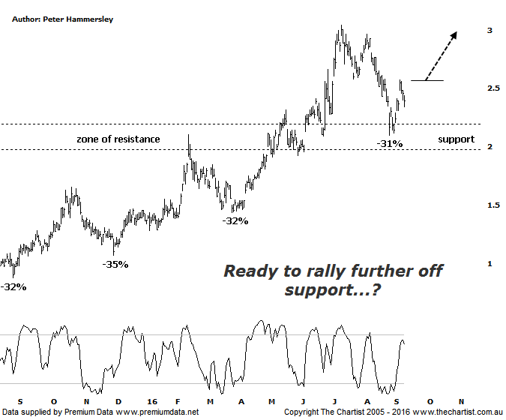
Bottom Line
12/9:
Daily Trend: Up
Weekly Trend: Down
Monthly Trend: Up
Support levels: $2.10 - $1.96
Resistance levels: $3.10 / $3.54
Video Analysis
Watch Video Analysis Here
Technical Discussion
Evolution Mining owns 5 gold and silver mines in Queensland and Western Australia and retains a 100% interest in all of them. The company was formed in October 2011 via a merger between Catalpha Resources and Conquest Mining. Recent results were lower than most brokers and analyst’s forecasts though it has turned the corner in being cash flow positive this year. For the year ending the 30th of June 2016 revenues increased 100% to A$1.33B. Net loss was A$24.3M against income of A$100.1M. Revenues echo the Cowal section increase from A$0K to A$375.3M and the Mungari section increase from A$0K to A$232.5M. The dividend yield is 1.2%. Broker/analyst consensus is currently “Buy”.
Reasons to be optimistic longer term:
→ The stake in the Ernest Henry mine should be earnings accretive.
→ Good potential for an increase in the dividend.
→ Gold hedging is in position which secures strong margins for a part of production, adding cash-flow security.
→ The recent acquisition of La Mancha increases scale.
→ Five equally sized Gold mines provide reliable production figures.
→ There is potential to prolong mine life from the existing 4.7 years.

Having embarked on a significant and impulsive leg higher the time was right to see a longer pause for breath from EVN although the sideways consolidation phase we were looking for hasn’t materialised. Instead price has come back down to test the old area of resistance which is now acting as support. As can be seen, a few buyers have stepped up over the past couple of weeks resulting in a reasonable bounce. One aspect of the chart we have talked about before has been the similarity in recent retracements. Since March 2015 all significant retracements have been around the 32% mark with one outlier at 35%. The recent pull-back fits nicely into this category meaning we are technically in a position to see a more significant rally. Gold itself has suffered as a consequence of analyst’s expectations that US interest rates are going to rise which is perceived as being negative for the yellow metal. All things being equal weakness is more than feasible although of course there’s no guarantee that the FED are going to act. Yes, eventually this will be the case but it’s by no means certain that it’s going to happen in the next couple of weeks which is when the next decision will be made. There is also the perception of gold being a safe haven which could provide a backdrop for the metal, especially if equity markets are going to embark on a deeper retracement which is more than possible. The bottom line though, is that we need to be cognizant of the patterns pertaining to the individual stocks themselves and not get caught up in the “will they or won’t they” argument.
Trading Strategy
Although price has rallied off the late August low volume has been low which is a trait that needs to change if something more bullish is going to unfold. However, if you are more aggressive then you could buy following a push up through the minor pivot high made on Wednesday at $2.57 with the initial stop needing to be set at $2.09. If you want to allow a little more wiggle room, then just beneath the lower boundary of the zone of support at $1.95 will suffice although obviously this increases the risk. We are going to remain sidelined for the moment but most of the stocks we cover are posturing for a leg higher so we may well put forward recommendations without doing formal reviews. For the moment though, a little more patience required.

Disclosure: Nick Radge holds

