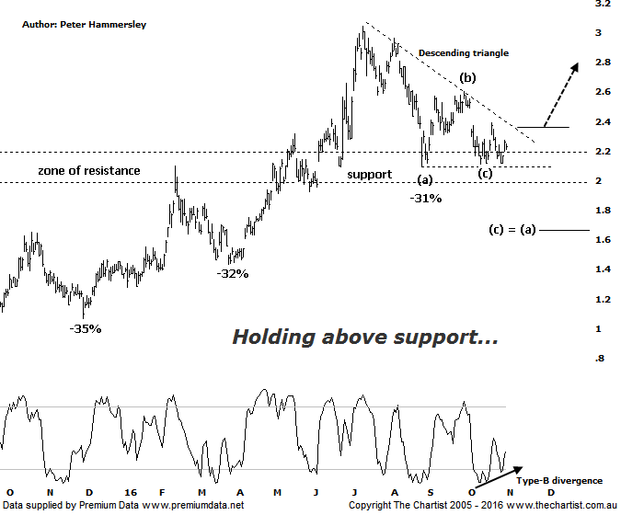

Bottom Line
1/11:
Daily Trend: Up
Weekly Trend: Down
Monthly Trend: Up
Support levels: $2.09 - $1.96 / $1.65
Resistance levels: $2.60 / $3.04 / $3.54
Video Analysis
Watch Video Analysis Here
Technical Discussion
Evolution Mining owns 5 gold and silver mines in Queensland and Western Australia and retains a 100% interest in all of them. The company was formed in October 2011 via a merger between Catalpha Resources and Conquest Mining. Recent results were lower than most brokers and analyst’s forecasts though it has turned the corner in being cash flow positive this year. For the year ending the 30th of June 2016 revenues increased 100% to A$1.33B. Net loss was A$24.3M against income of A$100.1M. Revenues echo the Cowal section increase from A$0K to A$375.3M and the Mungari section increase from A$0K to A$232.5M. The dividend yield is 1.4%. Broker/analyst consensus is currently “Buy”.
Reasons to be optimistic longer term:
→ Buyers remain committed around the zone of support.
→ Ernest Henry should add to a stronger second half.
→ Strong free cash flow.
→ Good potential for an increase in the dividend.
→ Gold hedging is in position which secures strong margins for a part of production, adding cash-flow security.
→ Five equally sized Gold mines provide reliable production figures.
→ There is potential to prolong mine life from the existing 4.7 years.

The question being asked last time was whether price was going to respect the zone of support or head down toward the wave equality projection as annotated just above $1.60. We can’t dismiss the possibility of heading south one final time toward that aforementioned target although one thing is for sure, buyers are stepping up to the plate during any dips in this area. As such, there is now scope to see a shallower corrective pattern which appears to be taking the form of a descending triangle at this stage. Waves-(a) through-(c) are in position meaning a little more posturing in this region should complete the structure. Should this prove to be the way forward we’ll be looking for a strong upside breakout, ideally coupled with increasing volume as this would provide confidence regarding strength being sustainable. There is also some bullish divergence in position on this daily chart although it’s the less potent Type-B variant with price making a double bottom whilst our oscillator has made a higher low. It’s only a slight tailwind but it’s worthy of mentioning. For the moment, we need to concentrate on the upper boundary of the triangle which essentially is acting as diagonal resistance. A push up through the trend line will be required before thinking in terms of hitting the initial target zone out of the pattern. We project this by measuring the depth of the triangle and projecting it from the breakout area which should take price up toward the $3.20 area again in reasonably quick fashion. As always, much is going to depend on the price of gold and although it has been rallying over the past few days the major headwind is interest rates in the US although this is already likely factored into price with most analysts suggesting rates are going to rise in December.
Trading Strategy
If you want exposure to the sector, then buy following a break through the upper trend line of the descending triangle whilst placing the initial stop just beneath the prior pivot low which at this stage sits at $2.11. If you want to allow a little more wiggle room, then place the stop just beneath the lower boundary of the zone support. The target is the measured move out of the triangle as mentioned above sitting at $3.20 which provides an acceptable risk-adjusted trade. There is no formal recommendation due to the possibility of increased volatility and the upcoming election in the US, plus the interest rate decision later down the track.

Disclosure: Nick Radge holds

