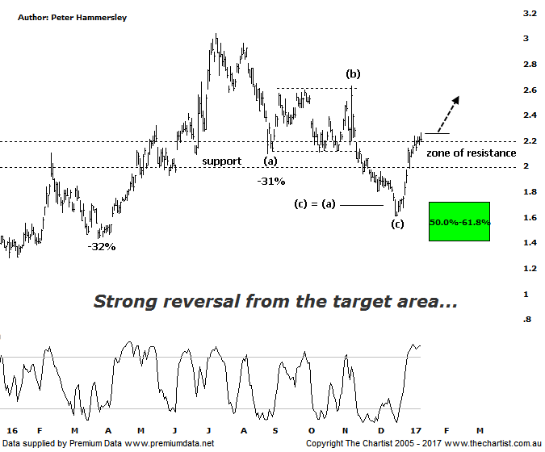

Bottom Line
12/1:
Daily Trend: Up
Weekly Trend: Up
Monthly Trend: Neutral
Support levels: $1.61/ 1.40
Resistance levels: $2.63 / $3.04 / $3.54
Video Analysis
Watch Video Analysis Here
Technical Discussion
Evolution Mining owns 5 gold and silver mines in Queensland and Western Australia and retains a 100% interest in all of them. The company was formed in October 2011 via a merger between Catalpha Resources and Conquest Mining. Recent results were lower than most brokers and analyst’s forecasts though it has turned the corner in being cash flow positive this year. For the year ending the 30th of June 2016 revenues increased 100% to A$1.33B. Net loss was A$24.3M against income of A$100.1M. Revenues echo the Cowal section increase from A$0K to A$375.3M and the Mungari section increase from A$0K to A$232.5M. The dividend yield is 1.6%. Broker/analyst consensus is currently “Buy”.
Reasons to be optimistic longer term:
→ Opportunity offered by the Cowal mine, being 30% of production.
→ Buyers remain committed around the zone of support.
→ Ernest Henry should add to a stronger second half.
→ Strong free cash flow.
→ Good potential for an increase in the dividend.
→ Gold hedging is in position which secures strong margins for a part of production, adding cash-flow security.
→ Five equally sized Gold mines provide reliable production figures.
“…As long as price can stay above the 61.8% retracement level at $1.40 there’s no reason to suspect something more sinister is in its early stages…” The recent low didn’t come close to getting through our make or break point which can only be viewed in a positive light. Despite the negativity surrounding gold recently, our stance has remained firm; yes, the correction in the yellow metal has been significant but it’s nothing out of the ordinary when considering the potency of the prior uptrend. On this particular chart, the (a)-(b)-(c) correction is absolutely ideal with the recent low terminating around the wave equality projection and the 50% - 61.8% retracement zone as shown. Not only has a corrective pattern down materialised, but off the recent lows price action has been exceptionally strong and impulsive in nature. Indeed, price has recently managed to get through the upper boundary of the zone of resistance. A sideways meander has transpired over the past week or so although as long as the next move is to the upside there’s no reason why something more bullish can’t unfold over the coming weeks. My only slight concern is that from a time perspective symmetry isn’t ideal. Normally a retracement will take at least 38.2% of the time taken by the prior trend which in this instance hasn’t been achieved. In fact, that date falls on the 24th of February meaning we still have to be slightly cautious, especially if momentum runs out of steam. For now though, we couldn’t have asked for a great deal more with the smaller degree patterns taking a turn for the better.
Trading Strategy
The small consolidation pattern does provide an entry if you want exposure to the sector. The strategy is to buy following a push above today’s high at $2.26 with the initial stop set at $1.865. This allows for the gap made a couple of weeks ago to be filled although it’s not a prerequisite to higher prices for this to transpire. A trailing stop will need to be used to manage the position. We will be making a formal recommendation this evening.

Disclosure: Nick Radge holds

