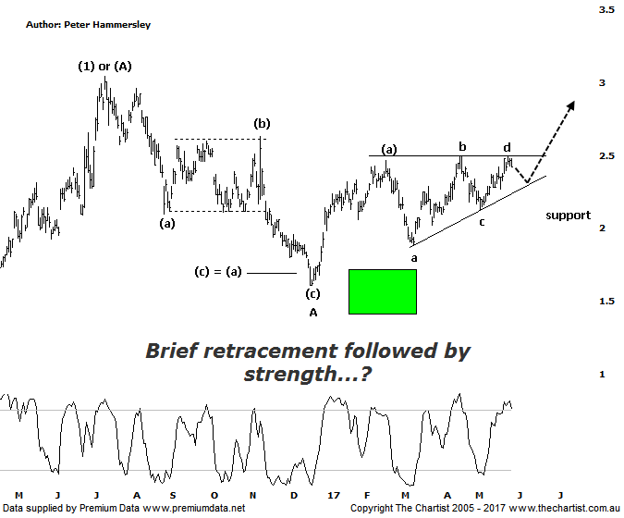
Bottom Line
29/5:
Daily Trend: Up
Weekly Trend: Up
Monthly Trend: Up
Support levels: $1.89 / $1.61
Resistance levels: $2.63 / $3.04 / $3.54
Video Analysis
Watch Video Analysis Here
Technical Discussion
Evolution Mining owns 5 gold and silver mines in Queensland and Western Australia and retains a 100% interest in all of them. The company was formed in October 2011 via a merger between Catalpha Resources and Conquest Mining. Recent results were lower than most brokers and analyst’s forecasts though it has turned the corner in being cash flow positive this year. For the six months ending the 31st of December 2016 revenues increased 17% to A$711.2M. Net income was A$136.7M against a loss of A$15.5M. Revenues highlight the Cowal section increase of 49% to A$228.4M and the Mungari section increase of 24% to A$130M. The dividend yield is 1.2%. Broker/analyst consensus is currently “Buy”.
Reasons to be optimistic longer term:
→ Cash generating, high margin business with a sustainable production outlook.
→ Debt repayment is ahead of schedule.
→ Opportunity offered by the Cowal mine, being 30% of production.
→ Strong free cash flow.
→ Good potential for an increase in the dividend.
→ Gold hedging is in position which secures strong margins for a part of production, adding cash-flow security.
→ Attempting to break up through a line of resistance.
After looking at the weekly chart last time, it’s back to the daily this evening which shows an interesting development. The consolidation that’s been unfolding since February of this year has taken the form of an ascending triangle which has followed a strong impulsive movement higher. Price will usually break in the direction of the prior trend meaning we must be on alert for an upside move. However, we’d like to see one brief probe down to complete wave-e of an Elliott Triangle before the breakout transpires. It’s not essential to hit the lower trend line within wave-e, so down toward $2.40 would be acceptable which in turn would complete intermediate degree wave-(b). Then EVN will be in a position to embark on another leg higher. Regarding a target, we simply measure the depth of the triangle and project it from the breakout which allows for a continuation up toward the July 2016 highs just above $3.00 which is still a move worthy of being involved with. From a time perspective, it’s difficult to see price heading too much higher due to the time element. Although a symmetrical 3-wave movement down has unfolded from the high of wave-(1) or-(A) it’s only taken a fraction of the time of the prior leg higher. Normally, a retracement will take at least 38.2% of the time taken by the prior trend which in this instance didn’t come close to being achieved. As such, we must assume that a corrective pattern is still in progress, albeit one with upside potential over the coming weeks. Clear rejection at the aforementioned target just above $3.00 would portend another leg down although we’ll revisit that scenario if and when the patterns allow. For now we’ll concentrate on the horizontal line of resistance and await an upside breakout - assuming one transpires.
Trading Strategy
If you want exposure to the gold sector then EVN offers potential, at least over the short to medium term. The strategy is to buy following a push above the recent pivot high at $2.50 with the initial stop placed just beneath the minor pivot low at $2.26. Either take profits at $3.00 or tighten the trailing stop at those higher levels. The risk/reward is acceptable though this trade is better suited for the more nimble amongst you. We will make a formal recommendation this evening in the position status page.

Disclosure: Nick Radge holds

