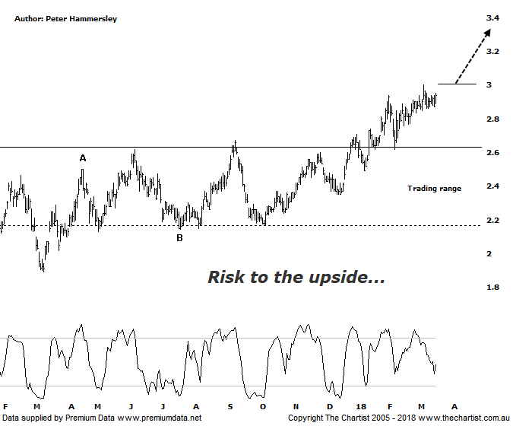

Bottom Line
19/3:
Daily Trend: Neutral
Weekly Trend: Up
Monthly Trend: Up
Support levels: $2.71 -$2.62 / $2.17 - $2.13
Resistance levels: $3.04 / $3.47 - $3.59
Video Analysis
Watch Video Analysis Here
Technical Discussion
Evolution Mining owns 5 gold and silver mines in Queensland and Western Australia and retains a 100% interest in all of them. The company was formed in October 2011 via a merger between Catalpha Resources and Conquest Mining. Recent results were lower than most brokers and analyst’s forecasts though it has turned the corner in being cash flow positive this year. For the six months ending the 31st of December 2017 revenues increased 10% to A$782.1M. Net income decreased 10% to A$122.5M. Revenues highlight the Ernest Henry section which increased from A$24.1M to A$175.3M and the Mt Carlton section which increased 17% to A$110.7M. Net income was offset by the share based payments expense which increased from A$371K to A$4.6M. The dividend yield is 1.4%. Broker/analyst consensus is currently “Hold”.
Reasons to be optimistic longer term:
→ Portfolio being upgraded through lowering costs and lengthening the average mine life.
→ Trading at a discount to its peers.
→ The acceleration of the exploration programme be a bullish catalyst.
→ Gearing cut to 10% following the Edna sale.
→ Offers an alternative to Newcrest for fund managers.
→ Strong free cash flow.
→ Good potential for an increase in the dividend.
→ Gold hedging is in position which secures strong margins for a part of production, adding cash-flow security.
In our review of the Gold Sub Sector (XGD) on Thursday we noted that choppy price action was the main theme, albeit the bias was to the upside. This is reason for concern over the short-term and keeps the door open for the sideways meander to continue in the yellow metal. Not surprisingly, similar price action has been witnessed here over the past few weeks although there’s no doubting the fact that the trend remains up which can only be positive. We’ve been concentrating on the weekly chart which shows that a larger corrective pattern is likely taking hold, albeit there is scope for higher prices over the coming months. In fact, price could head up toward $3.59 and still be within a larger corrective pattern. That level also aligns with all-time highs providing some confluence. In other words, it would take a push above $3.59 to start thinking in terms of a multi-year trend higher only being in its early stages. This evening though we are going to concentrate on the smaller degree patterns via the daily chart which shows that price has recently broken through the upper boundary of a Trading range. Price has also come back down to retest the breakout area where buyers stepped up to the plate which is about as textbook as it gets. As long as price can stay above what is now essentially a line of support around $2.65, the risk is to the upside. However, if our wave count is correct and EVN is heading higher within a larger corrective pattern we must keep our feet firmly on the ground when looking much further down the track. That said, we have our aforementioned bullish trigger firmly in place which is the 1.382 projection of wave-(A). We’ll talk about this during this evening’s video.
Trading Strategy
The small consolidation pattern that’s been forming over the past week or so does provide an opportunity if you like the sector and the stock. The strategy is to buy following a push up through the recent pivot high at $3.00 with the protective stop placed just beneath the prior pivot low and the line of support at $2.60. A reversal back into the trading range would be reason for concern meaning there would no longer be a reason to hold long positions. A trailing stop should be used to manage the position although a continuation up toward $3.60 should unfold as a minimum. There is no formal recommendation as we already have exposure to gold, plus the risk/reward from current levels isn’t enticing enough for us.

Disclosure: Nick Radge holds

