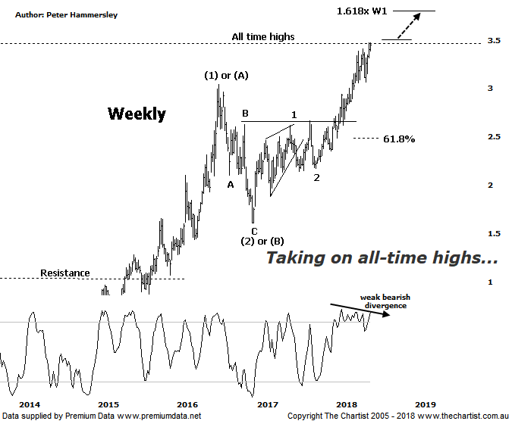

Bottom Line
12/6:
Daily Trend: Up
Weekly Trend: Up
Monthly Trend: Up
Support levels: $2.71 - $2.62 / $2.17 - $2.13
Resistance levels: $3.47 - $3.59
Video Analysis
Watch Video Analysis Here
Technical Discussion
Evolution Mining owns 5 gold and silver mines in Queensland and Western Australia and retains a 100% interest in all of them. The company was formed in October 2011 via a merger between Catalpha Resources and Conquest Mining. Recent results were lower than most brokers and analyst’s forecasts though it has turned the corner in being cash flow positive this year. For the six months ending the 31st of December 2017 revenues increased 10% to A$782.1M. Net income decreased 10% to A$122.5M. Revenues highlight the Ernest Henry section which increased from A$24.1M to A$175.3M and the Mt Carlton section which increased 17% to A$110.7M. Net income was offset by the share-based payments expense which increased from A$371K to A$4.6M. The dividend yield is 1.2%. Broker/analyst consensus is currently “Hold”.
Reasons to be optimistic longer term:
→ Portfolio being upgraded through lowering costs and lengthening the average mine life.
→ Trading at a discount to its peers.
→ The acceleration of the exploration programme be a bullish catalyst.
→ Gearing cut to 10% following the Edna sale.
→ Offers an alternative to Newcrest for fund managers.
→ Strong free cash flow.
→ Good potential for an increase in the dividend.
→ Gold hedging is in position which secures strong margins for a part of production, adding cash-flow security.
We've been running with the weekly chart of EVN recently which continues to look very good from an Elliott Wave perspective. However, price needed to get up through all-time highs as annotated to become confident that something much more bullish was evolving. This is still the case although at least price is posturing in exactly the right place. Interestingly, all-time highs were tagged and rejected on Wednesday although today was a better effort. Even accounting for the strong performance of gold in Australian dollar terms, it’s been a stellar effort by the company since late 2014 where price was sitting at a lowly $0.39 which just emphasises the potency of the trend since that time. As such, although we’d like price to break higher with some intent immediately, it wouldn’t come as a great surprise if more time was required before the next leg north kicks into gear. If blue sky territory is attained price should continue up to the 1.618 projection of wave-1 projected from the low of wave-2 providing a target at $3.80. This should be followed by several months of consolidation before the trend continues. The larger degree patterns which begin to the left of this chart offer a continuation up to just beneath $6.00 within a larger degree wave-(3) although that’s something to take a look at further down the track, assuming the smaller degree patterns continue to unfold as anticipated. The only slight headwind is bearish divergence on this weekly timeframe although it’s a weak example and needs to trigger before becoming significant. As such it’s something to watch only as opposed to advocating a leg South.
Trading Strategy
As we often state, we can’t make a formal recommendation when bearish divergence is on the agenda which is the case here, despite it not being a textbook example. If you are more aggressive at least wait until today’s high at $3.47 is breached before jumping on although a close above that level would provide more confidence regarding the next trend higher commencing. We’ll continue to watch only at this stage although if you are looking for a company within the sector then EVN is putting its hand up for recognition, especially as it’s been one of the best trending stocks on the ASX over the past few years. It’s also an alternative to Newcrest Mining.

