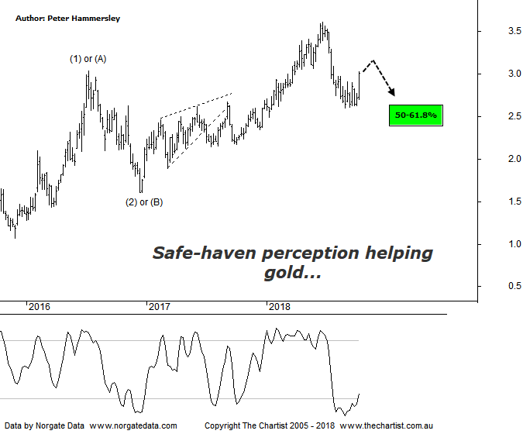

Bottom Line
12/10:
Daily Trend: Up
Weekly Trend: Up
Monthly Trend: Neutral
Support levels: $2.60 / $2.17 - $2.13
Resistance levels: $3.61
Video Analysis
Watch Video Analysis Here
Technical Discussion
Evolution Mining owns 5 gold and silver mines in Queensland and Western Australia and retains a 100% interest in all of them. The company was formed in October 2011 via a merger between Catalpha Resources and Conquest Mining. Recent results were lower than most brokers and analyst’s forecasts though it has turned the corner in being cash flow positive this year. For the year ending the 30th of June 2018 revenues increased 4% to A$1.54B. Net income increased 21% to A$263.4M. Revenues highlight the Ernest Henry section increase from A$163.3M to A$347.4M, the Mt Carlton section increase of 9% to A$214.8M and the Amortisation of debt establishment costs which decreased 90% to A$740K. The dividend yield is 2.8%. Broker/analyst consensus is currently “Hold”.
Reasons to be optimistic longer term:
→ The Cowal mine in NSW has been granted regulatory approval to increase its processing rate.
→ Has the potential to make acquisitions.
→ Portfolio being upgraded through lowering costs and lengthening the average mine life.
→ The acceleration of the exploration programme could be a bullish catalyst.
→ Gearing cut to 10% following the Edna sale.
→ Offers an alternative to Newcrest for fund managers.
→ Strong free cash flow.
→ Good potential for an increase in the dividend.
→ Gold hedging is in position which secures strong margins for a part of production, adding cash-flow security.
The perception that gold is a safe-haven in times of turmoil within the stock market has come to the rescue of the yellow metal over the past few sessions. The reason I say “perception” is because if we look back at history, the safe haven labelling doesn’t quite hold true. Still, for the moment the sell-off in the US has been enough for many traders and investors to look for safety and over the short-term it could be that gold remains in favour. Regarding the patterns here on the weekly chart nothing changes. That said, the straight-line movement lower prior to our last review gave every reason to be cautious, and this is still the case. Our line in the sand last time was the June 2017 high at $2.62 with a push beneath putting paid to any thoughts of seeing a textbook 5-wave movement higher off the December 2016 lows. This has now transpired. With no high probability alternate count available we’ll stick with the labelling although suffice to say clarity is now lacking. The big question now is whether equity markets are going to continue with their decline or regain some composure and head higher once again - which has been a trait of US indices. If it’s the prior, then something more bullish on this chart could unfold although it’s still going to take a push above the overhead target area at $3.23 before getting overly confident regarding a rotation back up toward the prior pivot high at $3.61. As strong as the rally has been over the past few sessions, we can only retain a neutral stance until the dust settles.
Trading Strategy
The surge higher over the past few sessions means there is no low-risk entry, even if you want to be involved in the sector, which at this juncture we don’t. As mentioned above, the rally in the yellow metal has been a reaction to increased volatility and weakness in equity markets meaning we need to be cautious regarding the sustainability of recent strength in the metal. Gold is back on our watchlist but we’re happy to stand aside until setups present themselves.

