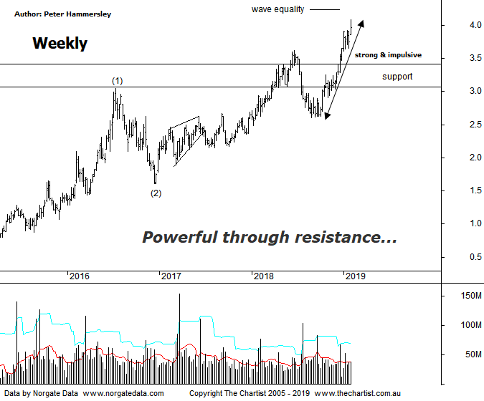

Bottom Line
1/2:
Daily Trend: Up
Weekly Trend: Up
Monthly Trend: Up
Support levels: $3.64 - $3.61 / $2.60 / $2.17 - $2.13
Resistance levels: N/A
Video Analysis
Watch Video Analysis Here
Technical Discussion
Evolution Mining owns 5 gold and silver mines in Queensland and Western Australia and retains a 100% interest in all of them. The company was formed in October 2011 via a merger between Catalpha Resources and Conquest Mining. Recent results were lower than most brokers and analyst’s forecasts though it has turned the corner in being cash flow positive this year. For the year ending the 30th of June 2018 revenues increased 4% to A$1.54B. Net income increased 21% to A$263.4M. Revenues highlight the Ernest Henry section increase from A$163.3M to A$347.4M, the Mt Carlton section increase of 9% to A$214.8M and the Amortisation of debt establishment costs which decreased 90% to A$740K. The dividend yield is 1.9%. Broker/analyst consensus is currently “Hold”.
Reasons to be optimistic longer term:
→ The Cowal mine in NSW has been granted regulatory approval to increase its processing rate.
→ Has the potential to make acquisitions.
→ Portfolio being upgraded through lowering costs and lengthening the average mine life.
→ The acceleration of the exploration programme could be a bullish catalyst.
→ Gearing cut to 10% following the Edna sale.
→ Offers an alternative to Newcrest for fund managers.
→ Strong free cash flow.
→ Good potential for an increase in the dividend.
→ Gold hedging is in position which secures strong margins for a part of production, adding cash-flow security.
The headline pattern last time was an ascending triangle, with price back then posturing for an upside breakout. This transpired immediately from where price hasn’t looked back. However, to be fair we weren’t expecting such a significant trend to develop, with our target being the pivot high made in June of last year around $3.60 likely being the full extent of any strength. However, not to be, with those levels being overcome by a substantial margin over the past few weeks. The improving price of gold has no doubt provided a helping hand and has now headed up through the psychological $1300 an ounce level. The corrective pattern higher we were looking for has now morphed into something more bullish meaning it’s time to take a step back and concentrate on the weekly chart. This shows that the rally that commenced in late 2014 is likely the initial stages of a more bullish longer term 5-wave movement higher. Price should be heading higher within wave-(3) which could take price up to the wave equality projection at $4.23 as a minimum. Usually, the third leg will extend meaning it needs to travel 1.618x length of wave-(1) projected from the low of wave-(2) which offers a rotation all the way up toward $5.85 although remember this is the weekly chart so it’s not going to happen overnight. Not only has the zone of resistance been overcome but a strong impulsive leg higher has taken price through all-time highs and into blue sky territory. There is no upside target, so we’ll simply go with the flow until evidence of distribution materialises. For now, buyers are in firm control.
Trading Strategy
“…I’m going to put forward a formal recommendation this evening. The strategy is to buy following a break above today’s high at $3.26 with the protective stop placed beneath yesterday’s low at $3.13 which is a very aggressive strategy. We’ll use a trailing stop to manage the position although as a minimum we’d be looking for price to head up toward $3.60 which offers an acceptable risk/reward…” We continue to hold our long position, with the trailing stop adjusted up to $3.71 recently to reduce the risk. We’ll leave this well alone for the moment as we don’t want to be stopped out prematurely during normal market noise. We need to allow the trade room to breathe which in turn allows a small profit to potentially turn into a large one. If you aren’t already involved then stand aside as there is no low-risk entry at this stage.

