CSL Limited (CSL)
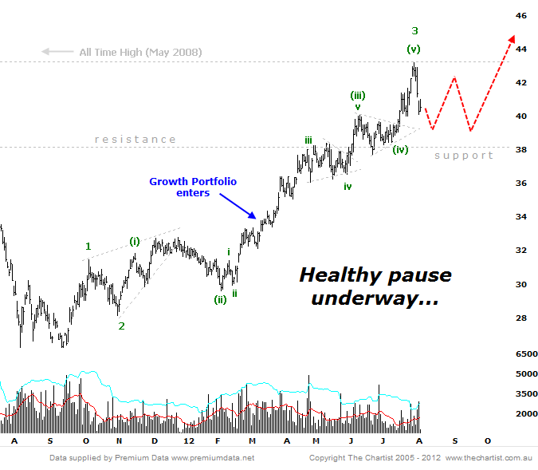
Bottom Line
6/8:
EW Trend: Impulsive
Price Trend: Up
Trend Strength: Strong
Video Analysis Watch Video Analysis Technical Discussion

6/8:
LAYMANS:
In his last review Pete highlighted the ongoing bullish case for CSL and suggested some more pause in the near term was probable. Well, we didn't get much and price enjoyed another thrust higher to tag its all time highs set back in 2008. This new found strength only marginally changes the outlook, albeit only extends our upside potential. Not surprisingly profit takers jumped in at the old levels. This is a very common occurrence and is a specific reason why we never buy stocks sitting just below significant levels of resistance. Chances are that profit takers will unload positions for fear of prices reversing sharply lower. Usually a pause is all that is warranted and those same sellers will find themselves chasing new highs when the time comes. We feel that time will certainly come for CSL but in the interim we should expect a few months of sideways activity before the trend continues.

TECHNICAL:
One of the most difficult aspects of Elliott Wave is the application of extensions. CSL, in its strong trending state, is essentially 'extending' or creating waves within waves. When this occurs we need to recalibrate the count which has been done for tonight. However, its also helpful when doing this to include other important data points, such as this all time high. Probability suggests that a test of an all-time high has a larger weighting on larger wave degree's which is why we've now suggested the recent high is a more probable wave-3. A rotation between this high point and recent support will portend a wave-4 is taking shape and will then lead to the next move higher to all time highs. Trading CSL over the coming months may be a little tricky should a corrective wave take shape, but patience will be rewarded with significantly higher prices to come. A break back down through $38.00 is cause for concern and damaging to near term momentum.
Trading Strategy
6/8:
The Growth Portfolio entered new positions back in March circa $33.50. The trailing stop currently runs at $36.00 and will continue to follow the trend higher should price push up further. For discretionary traders we expect a month or two of sideways congestion so we feel its best to either buy weakness back toward $38.00 if offered the opportunity or await the consolidation to unfold then buy any renewed break higher. All in all CSL looks extremely positive and a $50 handle is highly anticipated.

