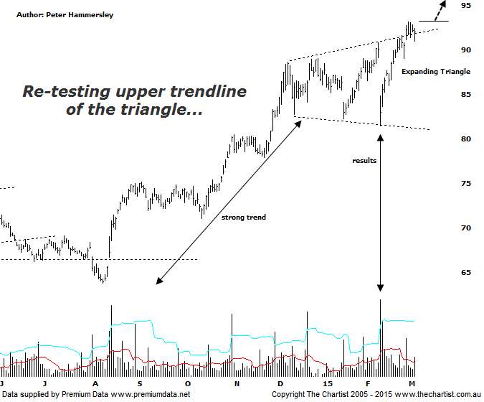

Bottom Line
5/3:
Daily Trend: Up
Weekly Trend: Up
Monthly Trend: Up
Support levels: $81.48 / $77.30 / $74.11
Resistance levels: $93.15
Video Analysis
Watch Video Analysis Here
Technical Discussion
CSL conducts research of biopharmaceutical products. Following positive results it continues into the development and manufacturing stages before distributing the product. It operates in three segments; CSL Behring, Intellectual Property licensing and Other Human Health. The latter consists of CSL Bioplasma and CSL Biotherapies. Recently the company has acquired the Novartis flu vaccine business now making it the world’s second largest manufacturer. Whilst this may generate near term head-winds, longer term it’s expected to increase its profile significantly and turn a loss maker into a globally competitive business. Broker / Analyst consensus is currently “Buy”. The dividend yield is 1.6%.
Reasons to be bullish longer term:
→ FDA approval for the long-acting recombinant Factor IX fusion protein would be extremely positive for FY16.
→ The recent purchase of Novartis’ flu vaccine should be accretive over the longer term.
→ Ongoing acquisitions offer strong gains in synergy.
→ Brokers upbeat on new deal with some upgrades.
→ CSL appears to you have the upper hand over its competitors who were being perceived as a risk.
Results had just been issued during our last review which resulted in a substantial sell-off. On the positive side of things though the lower boundary of the expanding triangle brought in a few buyers, who have continued to chase price higher. In fact it’s been a decent trend over the past three weeks with new all-time highs achieved. We often state on these pages that we can’t read too much into one day’s price action with the chart here being a case in point. Yes, the initial reaction to results resulted in a large percentage decline although it proved to be a one of event. It’s the two or three days after the announcement that provide a clue as to whether something more sinister is going to unfold which obviously in this case it hasn’t. Moving back to the expanding triangle, we can offer a target by measuring the depth of the pattern and projecting it from the breakout. This provides a target up around the $103.00 region which still offers plenty of upside from current levels. Also notice that the upper boundary of the triangle was briefly penetrated today although the close was near the highs of the session which again can only be viewed in a positive light. The only slight negative is that bearish divergence is evident on both the daily and weekly time frames. That said, in regard to the prior it’s the less potent Type-B variant which usually isn’t major reason for concern. On the weekly chart (not shown) the divergence has yet to trigger which again means it’s something to watch only as opposed to being major reason for concern.
Trading Strategy
If you want to be involved with the strong uptrend the strategy is to buy following a break above the recent pivot high at $93.15 whilst placing the initial stop at $88.99. The medium term target is the measured move out of the triangle mentioned above at $103.00 though with blue sky territory recently achieved there is no reason why the trend can’t continue onwards and upwards. Looking at the larger degree patterns it would take a break beneath the last significant pivot low at $63.77 to suggest a major top is in position although a decline to those levels is a low probability scenario. The risk is still to the upside.

