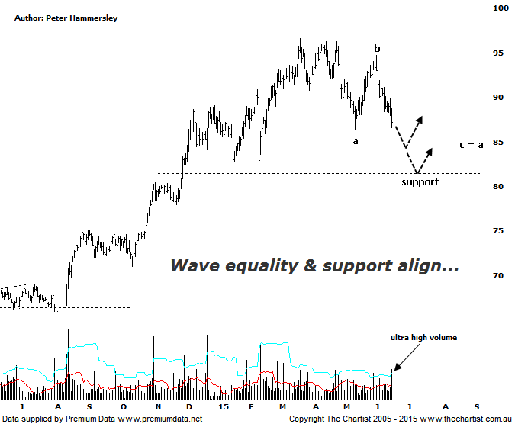

Bottom Line
17/6:
Daily Trend: Down
Weekly Trend: Down
Monthly Trend: Up
Support levels: $84.41 / $81.48 / $80.18 / $76.31
Resistance levels: $94.71 / $96.60
Video Analysis
Watch Video Analysis Here
Technical Discussion
CSL conducts research of biopharmaceutical products. Following positive results it continues into the development and manufacturing stages before distributing the product. It operates in three segments; CSL Behring, Intellectual Property licensing and Other Human Health. The latter consists of CSL Bioplasma and CSL Biotherapies. Recently the company has acquired the Novartis flu vaccine business now making it the world’s second largest manufacturer. Whilst this may generate near term head-winds, longer term it’s expected to increase its profile significantly and turn a loss maker into a globally competitive business. Broker / Analyst consensus is currently “Hold”. The dividend yield is 1.7%.
Reasons to be bullish longer term (caution short term):
→ The operating environment remains encouraging.
→ FDA approval for the long-acting recombinant Factor IX fusion protein would be extremely positive for FY16.
→ The recent purchase of Novartis’ flu vaccine should be accretive over the longer term.
→ Ongoing acquisitions offer strong gains in synergy.
→ Brokers upbeat on new deal with some upgrades.
Our focus of attention during the last review was on an expanding triangle which in normal circumstances is a bullish proposition. The problem last time was that the breakout lacked conviction with a push beneath $90.81 raising a red flag. That’s exactly what transpired with the downturn kicking in almost immediately. Not that it’s been a significant leg lower is it certainly hasn’t but a longer pause for breath is taking place. In fact since December of last year price has been meandering sideways meaning traction for the moment has been lost. However, the prior trend is exceptional to say the least so a healthy retracement or even a consolidation pattern is perfectly acceptable and should lay the foundations for another leg higher in the not too distant future. First of all, price should head down to the wave equality projection as annotated sitting at $84.41 which isn’t too far beneath current levels. This sits slightly above the minor line of support providing some confluence at those slightly lower levels. For the medium term bullish case to remain in place it’s important that support holds, meaning a break beneath $80.00 would likely induce a deeper and longer pull-back. Not our highest expectation at this point in time but a level to keep a close eye on should downside momentum gain traction. One thing we pointed out back in April was Type-A bearish divergence on the weekly time frame (not shown) which is always reason to sit up and take notice. This subsequently triggered which has no doubt been a drag on the share price. Our indicator has almost reached the oversold position and although this doesn’t automatically portend a leg higher it could well fully unwind as price hits our aforementioned target zone which can only be a positive.
Trading Strategy
We have said many times before that it’s always a good idea to have some strong trending stocks in your portfolio and they don’t come much better this. That said, the time for jumping on isn’t right here and now. We need to let the bearish divergence mentioned above head to slightly lower levels which should allow price to head down toward the zone of support, or at least the wave equality projection sitting slightly above. This means a little more patience is required over the coming weeks which should be well rewarded later down the line. Definitely one for the short-term watch list if you want to be involved in a solid company that has continued upside potential.

