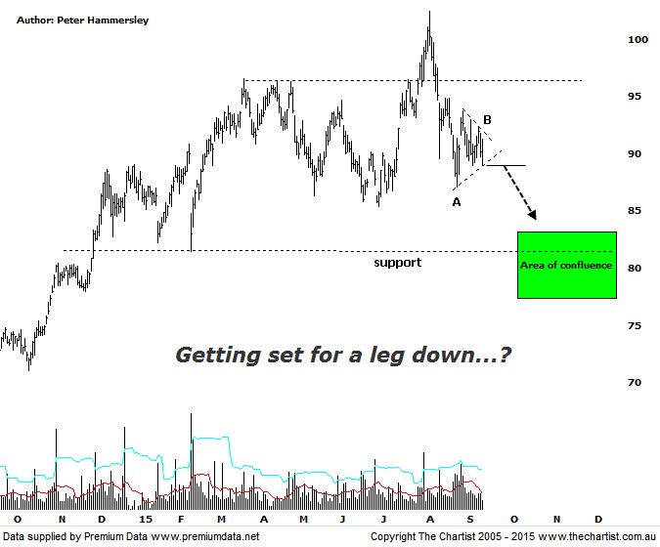

Bottom Line
21/7:
Daily Trend: Neutral
Weekly Trend: Neutral
Monthly Trend: Neutral
Support levels: $85.40 / $81.48 / $78.53 / $77.07
Resistance levels: $94.87 / $102.43
Video Analysis
Watch Video Analysis Here
Technical Discussion
CSL conducts research of biopharmaceutical products. Following positive results it continues into the development and manufacturing stages before distributing the product. It operates in three segments; CSL Behring, Intellectual Property licensing and Other Human Health. The latter consists of CSL Bioplasma and CSL Biotherapies. Recently the company has acquired the Novartis flu vaccine business now making it the world’s second largest manufacturer. Whilst this may generate near term head-winds, longer term it’s expected to increase its profile significantly and turn a loss maker into a globally competitive business. Broker / Analyst consensus is currently “Buy”. The dividend yield is 2.0%.
Reasons to remain bullish (short term weakness feasible).
→ The operating environment remains encouraging.
→ FDA approval for the long-acting recombinant Factor IX fusion protein would be extremely positive for FY16.
→ The recent purchase of Novartis’ flu vaccine should be accretive over the longer term.
→ Ongoing acquisitions offer strong gains in synergy.
→ Brokers upbeat on new deal with some upgrades.
CSL was posturing for a breakout during our last review with a push up through the line of resistance required to trigger a decent leg higher. However, although the breakout transpired price reversed almost immediately which of course has been a common theme over the past few months. Many companies we cover have broken out only to fail miserably to get on with the job. Unfortunately it’s just part and parcel of the increased volatility in global equity markets. What we are left with now is a corrective pattern down to the pivot low made on the 25th of August which has been followed by a consolidation pattern, taking the form of a symmetrical triangle. The risk now is that the lower boundary of the triangle is penetrated which could trigger another leg south into the target area as annotated. The wave equality projection of a larger A-B-C correction sits slightly beneath the 61.8% retracement level of the prior leg higher which provides us with some confluence. It’s quite a large target zone but it also aligns with another area of support meaning our focus of attention needs to be concentrated on the $80.00 region over the coming weeks – assuming a downside breakout transpires. Should price break higher out of the consolidation pattern we’d expect to see further sideways chop in this region for the foreseeable future. In fact if this is the way forward it could well be that we are looking at an H&S pattern in the making though we’ll take a closer look at this during this evening’s video.
Trading Strategy
If you’re looking for short side trades then the bearish trigger here is the lower boundary of the triangle with a push beneath likely triggering a leg down into the target zone. The initial stop would need to be placed just above the recent pivot high at $92.95 which offers an acceptable risk/reward trade and a low risk entry. One for the more aggressive trader in the current market volatility which as we have been saying over the past few weeks makes placement of stops extremely difficult. It increases the chances that what is now “normal market noise” is going to result in stops being hit prematurely.

