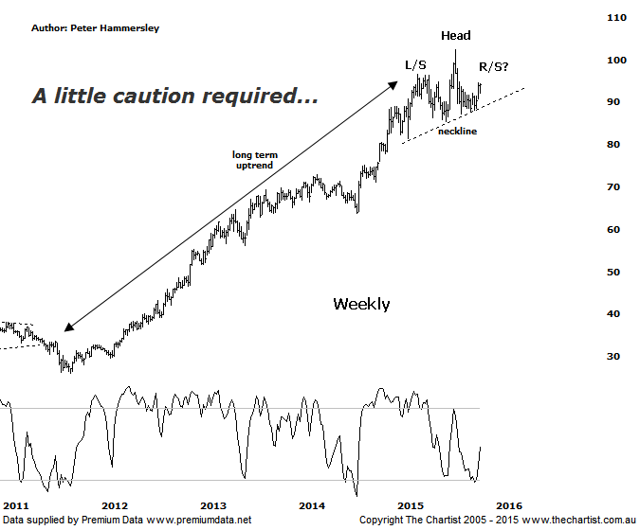

Bottom Line
3/10:
Daily Trend: Up
Weekly Trend: Up
Monthly Trend: Up
Support levels: $85.40 / $83.10 / $78.54
Resistance levels: $102.43
Video Analysis
Watch Video Analysis Here
Technical Discussion
CSL conducts research of biopharmaceutical products. Following positive results it continues into the development and manufacturing stages before distributing the product. It operates in three segments; CSL Behring, Intellectual Property licensing and Other Human Health. The latter consists of CSL Bioplasma and CSL Biotherapies. Recently the company has acquired the Novartis flu vaccine business now making it the world’s second largest manufacturer. Whilst this may generate near term head-winds, longer term it’s expected to increase its profile significantly and turn a loss maker into a globally competitive business. Broker / Analyst consensus is currently “Buy”. The dividend yield is 1.9%.
Reasons to remain bullish longer term (short term weakness feasible).
The operating environment remains encouraging.
→ FDA approval for the long-acting recombinant Factor IX fusion protein would be extremely positive for FY16.
→ The recent purchase of Novartis’ flu vaccine should be accretive over the longer term.
→ Ongoing acquisitions offer strong gains in synergy.
→ Brokers upbeat on new deal with some upgrades.
During our last look at CSL a symmetrical triangle appeared to be forming which followed a strong leg lower. This kept the door open for a rotation down toward the next line of support around $80.00. However, the symmetrical triangle continued to evolve with the upper boundary being overcome just over a week ago. Before we get overly optimistic with the recent show of resilience though it’s worth taking a look at the weekly chart which is where we’ll focus our attention this evening. The main thing to take away initially is the potency of the prior trend that commenced all the way back in 2011. A gain of 292% was the end result of the subsequent leg higher which is a nice trend if you were on for the ride. The most interesting aspect of the chart now is a potential Head & Shoulders pattern with the right shoulder looking like it’s in its final stages. A continued push higher toward $96.00 would be enough to complete the pattern and put us on alert for a deeper retracement. However, whichever pattern you care to mention they’re only significant when they trigger. In this instance that means a push beneath the neckline of the structure would be required before suggesting a significant top is in position. Remember we are looking at the larger degree patterns via the weekly chart here so it’s going to take some time for the reversal pattern to complete – assuming it does. A push up through the recent pivot high at $102.43 invalidates the H&S and opens the door for the longer term uptrend to continue unabated.
Trading Strategy
With price basically meandering sideways since March of this year the best thing to do is stand aside and await the outcome of the potential H&S reversal pattern. If it does prove to be significant then a shorting opportunity could present itself a little further down the track although it would be an aggressive stance to be a seller looking at the strength of the prior trend. Also, the broader market would need to take a turn for the worse to get too interested in short-setups. Either way for the moment we’ll view from the sidelines only, at least until the sideways movement resolves itself.

