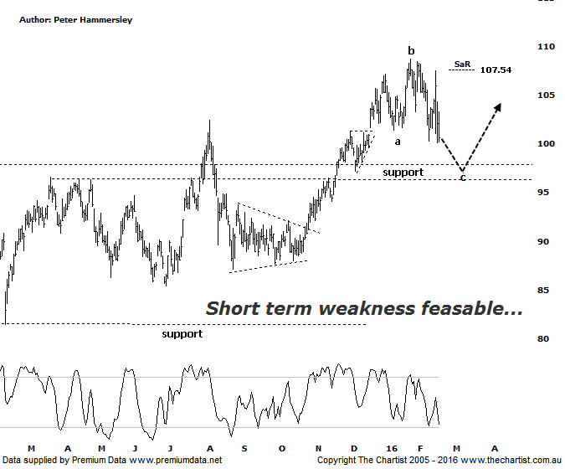
Bottom Line
18/2:
Daily Trend: Down
Weekly Trend: Down
Monthly Trend: Up
Support levels: $99.34 / $85.40 / $83.10
Resistance levels: $108.68
Video Analysis
Watch Video Analysis Here
Technical Discussion
CSL conducts research of biopharmaceutical products. Following positive results it continues into the development and manufacturing stages before distributing the product. It operates in three segments; CSL Behring, Intellectual Property licensing and Other Human Health. The latter consists of CSL Bioplasma and CSL Biotherapies. Recently the company has acquired the Novartis flu vaccine business now making it the world’s second largest manufacturer. Whilst this may generate near term head-winds, longer term it’s expected to increase its profile significantly and turn a loss maker into a globally competitive business. For the six months ending the 31st of December revenues increased 10% to $3.14B. Net income increased 4% to $718.8M. Revenues reveal the Bio CSL segment increase from $255.1M to $531.7M. Broker / Analyst consensus is currently “Hold”. The dividend yield is 1.7%.
Reasons to remain bullish longer term (short term weakness feasible).
→ First half results were strong with plasma beating expectations. FY16 guidance was also reaffirmed.
→ Management are confident that its rFIX ldelvion is going to be the standard in the haemophilia B market.
→ The operating environment remains encouraging.
→ The recent purchase of Novartis’ flu vaccine should be accretive over the longer term.
→ Ongoing acquisitions offer strong gains in synergy.
Price had broken higher out of a small pennant on the day of our last review taking the stock into blue sky territory which is never a bad characteristic. It goes without saying that the longer term uptrend remains firmly in position with no indication right here and now that a significant top is about to be made. In fact, on the daily chart shown here there is some minor bullish divergence in position although at this stage it has yet to trigger. If it does just that, then the door is open to continue up through the recent pivot high at $108.68 by a reasonable margin. There is no high probability target area at this stage although there is nothing wrong with going with the flow and waiting for signs of distribution before thinking in terms of a corrective pattern taking hold. Looking at the more recent price action shows a potential flat a-b-c correction which is a pattern that often crops up during strong trends. When buyers are committed (as they are here) the deeper zigzag often fails to materialise which is solely because investors are waiting in the wings happily jumping on during any small retracement. It almost becomes a self-fulfilling prophecy. A push beneath yesterday’s low at $100.13 would imply a continuation down toward the zone of support is going to be the way forward although even this wouldn’t be major reason for concern. Indeed, it would just present another buying opportunity following signs of strength at those slightly lower levels.
Trading Strategy
With the potential to head down toward the line of support I don’t see any compelling reason to jump on right here and now just for the sake of it. However, you could certainly use our SaR indicator as an entry mechanism which currently sits at $107.54. With until price closes above the indicator before initiating positions. Should the slightly deeper retracement unfold there would be reason to buy following signs of strength around the zone of support. It’s never a bad idea to have some strong trending stocks in your portfolio, especially for those that like to trade more aggressive reversal patterns.

