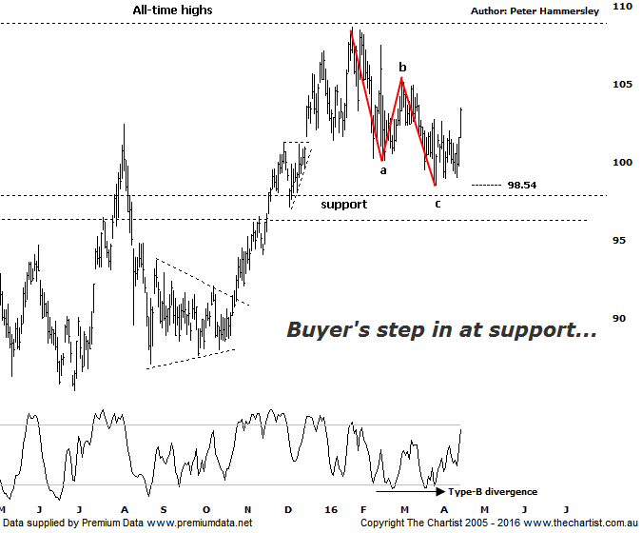

Bottom Line
18/4:
Daily Trend: Up
Weekly Trend: Neutral
Monthly Trend: Up
Support levels: $96.92 / $85.40
Resistance levels: $108.68
Video Analysis
Watch Video Analysis Here
Technical Discussion
CSL conducts research of biopharmaceutical products. Following positive results, it continues into the development and manufacturing stages before distributing the product. It operates in three segments; CSL Behring, Intellectual Property licensing and Other Human Health. The latter consists of CSL Bioplasma and CSL Biotherapies. Recently the company has acquired the Novartis flu vaccine business now making it the world’s second largest manufacturer. Whilst this may generate near term head-winds, longer term it’s expected to increase its profile significantly and turn a loss maker into a globally competitive business. For the six months ending the 31st of December revenues increased 10% to $3.14B. Net income increased 4% to $718.8M. Revenues reveal the Bio CSL segment increase from $255.1M to $531.7M. Broker / Analyst consensus is currently “Hold”. The dividend yield is 1.6%.
Reasons to remain bullish longer term (short term weakness feasible).
→ Solid industry growth is anticipated.
→ First half results were strong with plasma beating expectations. FY16 guidance was also reaffirmed.
→ Management are confident that its rFIX ldelvion is going to be the standard in the haemophilia B market.
→ The operating environment remains encouraging.
→ The recent purchase of Novartis’ flu vaccine should be accretive over the longer term.
→ Ongoing acquisitions offer strong gains in synergy.

We were concentrating on a bullish symmetrical triangle during our last review though as it turns out the breakout was to the downside. Not that this moves us to a bearish stance as it certainly doesn’t, especially with price recently bouncing hard from the zone of support as annotated. The Triangle has morphed into a more conventional a-b-c although the wave equality projection at $96.92 wasn’t quite tagged. Theoretically those slightly lower levels could still be challenged although having seen price action over the past few days it’s not a prerequisite to hit those lower levels before the longer term uptrend kicks back into gear. One thing we can’t overlook is the potency of the prior trend which commenced all the way back in September 2011. It’s pretty much been a straight line rise when looking at the weekly chart (not shown) with any dips that have materialised met with strong buying demand. This trait appears to want to continue which can only bode well for the future. As long as the aforementioned level at $96.92 remains intact there’s no reason to deviate from our bullish expectations. At the moment price is being helped by bullish divergence although our oscillator is now well on its way to hitting the overbought position meaning that particular tailwind isn’t going to be around for too much longer. That said, there are still plenty of positive aspects of this chart which all point to the next major move being to the upside. Fundamentally there is still a lot to like about this stock with several points mentioned in the above section. Looking back at broker consensus shows that they haven’t been overly positive about the company over the years although price action speaks for itself which as far as we’re concerned is much more significant.
Trading Strategy
Our bullish trigger wasn’t penetrated following our last review meaning we continue to remain on the sidelines. We can take heart in the zone of support holding firm so if you want to be involved then accumulate partial positions right here and now. Place the initial stop just beneath the recent pivot low and the wave equality projection at $96.90. With the company posturing to take on all-time highs there is no high probability target area meaning a trailing stop will need to be used to manage the position. There is no formal recommendation here but a low risk entry is presenting itself should you want to be involved in an exceptionally strong trending stock - which of course is never a bad idea.

