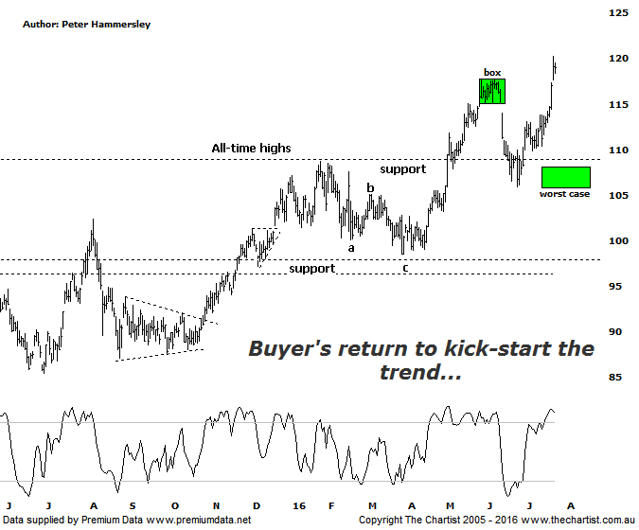

Bottom Line
22/7:
Daily Trend: Up
Weekly Trend: Up
Monthly Trend: Up
Support levels: $108.07 - $105.82 / $98.54 - $97.17
Resistance levels: $N/A
Video Analysis
Watch Video Analysis Here
Technical Discussion
CSL conducts research of biopharmaceutical products. Following positive results, it continues into the development and manufacturing stages before distributing the product. It operates in three segments; CSL Behring, Intellectual Property licensing and Other Human Health. The latter consists of CSL Bioplasma and CSL Biotherapies. Recently the company has acquired the Novartis flu vaccine business now making it the world’s second largest manufacturer. Whilst this may generate near term head-winds, longer term it’s expected to increase its profile significantly and turn a loss maker into a globally competitive business. For the six months ending the 31st of December revenues increased 10% to $3.14B. Net income increased 4% to $718.8M. Revenues reveal the Bio CSL segment increase from $255.1M to $531.7M. Broker / Analyst consensus is currently “Hold”. The dividend yield is 1.4%.
Reasons to remain bullish longer term (short term weakness feasible).
→ Plasma sales globally grew over 8% in 2015.
→ Solid industry growth is anticipated.
→ Results were strong with plasma beating expectations. FY16 guidance was also reaffirmed.
→ Management are confident that its rFIX ldelvion is going to be the standard in the haemophilia B market.
→ The operating environment remains encouraging.
→ Ongoing acquisitions offer strong gains in synergy.

A small box pattern was in position during our last review which followed a strong impulsive movement higher that kicked in during late June. However, the problem over the short-term was that bearish divergence was in place and had already triggered. A break down through the lower boundary of the box portended a rotation down toward the line of support which showed good confluence with the typical retracement zone of the aforementioned leg higher. Divergence usually proves to be significant one way or the other and in this instance that’s exactly what transpired. Our “worst-case” target area has been tagged although once again it’s brought out the buyers with a good leg higher kicking in over the past few weeks. One thing is for sure, this is an exceptionally strong trending stock over the long-term and with plenty of blue sky ahead there’s no way of knowing where the trend is going to terminate. What we do know is that at this stage there is no serious sign of distribution which means we’ll just go with the trend until it starts to falter. If we are to be slightly picky we can say that latest leg higher has been coupled with lower than average volume which isn’t ideal though until sellers come out of the woodwork, it’s not overly concerning. The company is looking overbought on both the daily and weekly charts although with no divergence in place I wouldn’t read too much into it. These indicators can remain overbought for significant periods of time - even many months when the trend is strong which has been witnessed in this stock over the years.
Trading Strategy
We have been holding this stock since May and although some patience has been required price finally appears to be heading higher with some conviction. We’ll leave the trailing stop as is for the moment although we’ll be looking to tighten it next week if a little more traction can be gleaned. In fact, I’ll be looking to adjust to break even as soon as possible to provide us with another risk-free trade. If you aren’t already involved there’s no reason to jump on here with a micro consolidation pattern needing to be seen as a minimum before looking to initiate new long positions.

