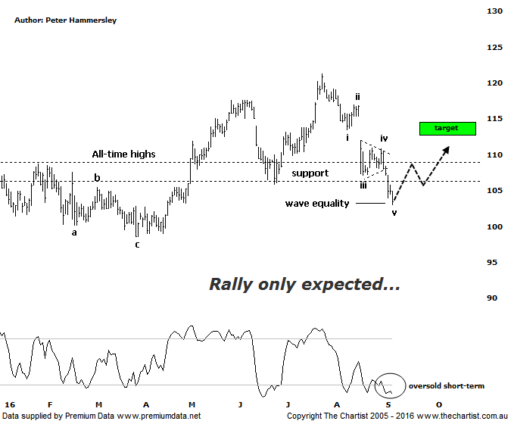

Bottom Line
6/9:
Daily Trend: Down
Weekly Trend: Down
Monthly Trend: Down
Support levels: $103.03/ $98.54 - $97.17
Resistance levels: $121.25
Video Analysis
Watch Video Analysis Here
Technical Discussion
CSL conducts research of biopharmaceutical products. Following positive results, it continues into the development and manufacturing stages before distributing the product. It operates in three segments; CSL Behring, Intellectual Property licensing and Other Human Health. The latter consists of CSL Bioplasma and CSL Biotherapies. Recently the company has acquired the Novartis flu vaccine business now making it the world’s second largest manufacturer. Whilst this may generate near term head-winds, longer term it’s expected to increase its profile significantly and turn a loss maker into a globally competitive business. For the year ending the 30th of June 2016 revenues increased 9% to $6.13B. Net income decreased 10% to $1.24B. Revenues reflect the Seqirus section increase of 72% to $731.5M. Broker / Analyst consensus is currently “Hold”. The dividend yield is 1.6%.
Reasons to remain bullish longer term (short term weakness feasible).
→ Plasma sales globally grew over 8% in 2015.
→ Solid industry growth is anticipated.
→ Management are confident that its rFIX ldelvion is going to be the standard in the haemophilia B market.
→ The operating environment remains encouraging.
→ Ongoing acquisitions offer strong gains in synergy.
It’s only couple of weeks since our last look at CSL although some interesting developments have taken place since that time meaning we need to take another look. First of all, the zone of support has been overcome which means it’s now going to be acting as resistance on the way back up - assuming a rally unfolds. The other interesting aspect of the chart is that a clearly defined 5-wave movement down appears to have unfolded off the 25th of July high. In fact, the wave equality projection sits at $103.03 which was tagged today. If Elliott Wave analysis is going to prove to be significant here, then we’d expect a countertrend rally to unfold over next few days. Not that we’d anticipate a significant leg higher to unfold but a push up into the typical retracement zone as annotated between $112.41 – 114.96 is more than feasible over the coming weeks. This of course is assuming that an interim low is already in position which is by no means set in stone. Taking a look at the weekly chart (not shown) shows that the bearish divergence mentioned last time is no longer a headwind with our oscillator already sitting in the oversold position. This is also true on the daily chart shown here which again adds weight to the case for some type of a countertrend movement higher to unfold over the short-term. Should today's low at $103.00 be penetrated then price could head down toward the next zone of support around $98.54.
Trading Strategy
As we’ve mentioned several times before, this time around results season has caused some volatility both to the up and to the downside. Unfortunately, CSL has been on the receiving end of results which is reiterated by the gap lower following the earnings release on the 17th of August from where sellers have remained firmly in control. A significant as the decline has been, there is reason to expect a bounce although there isn’t enough in it to warrant making a formal recommendation, especially as we have so many open positions currently. If you want to be involved, you could initiate long positions following a push up through yesterday’s high at $105.73 with the initial stop set at $102.90. Look to take profits when price hits the typical retracement zone.

