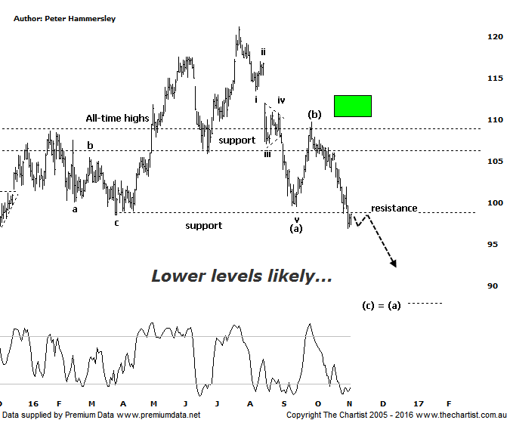

Bottom Line
4/11:
Daily Trend: Down
Weekly Trend: Down
Monthly Trend: Down
Support levels: $88.00 / $85.40
Resistance levels: $109.75 / $121.25
Video Analysis
Watch Video Analysis Here
Technical Discussion
CSL conducts research of biopharmaceutical products. Following positive results, it continues into the development and manufacturing stages before distributing the product. It operates in three segments; CSL Behring, Intellectual Property licensing and Other Human Health. The latter consists of CSL Bioplasma and CSL Biotherapies. Recently the company has acquired the Novartis flu vaccine business now making it the world’s second largest manufacturer. Whilst this may generate near term head-winds, longer term it’s expected to increase its profile significantly and turn a loss maker into a globally competitive business. For the year ending the 30th of June 2016 revenues increased 9% to $6.13B. Net income decreased 10% to $1.24B. Revenues reflect the Seqirus section increase of 72% to $731.5M. Broker / Analyst consensus is currently “Hold”. The dividend yield is 1.7%.
Reasons to remain bullish longer term (short term weakness feasible).
→ A new drug offers excellent upside if trial results positive in November.
→ Underlying business shows solid sales growth.
→ Solid industry growth is anticipated.
→ Management are confident that its rFIX ldelvion is going to be the standard in the haemophilia B market.
→ Ongoing acquisitions offer strong gains in synergy.
Looking at the weekly chart (not shown) shows that the retracement over the past few months has been the most significant since the strong trend developed in September 2011. This is significant in itself as it always keeps the door open to see a much deeper retracement though at this stage it’s by no means a foregone conclusion. We are still looking for a corrective pattern down despite price action starting to look impulsive to the downside. During our last review, the ideal situation was to see slightly higher prices, taking price into the typical retracement zone although this wasn’t to be. However, the 50% retracement level came within a whisker of being tagged which in this instance is close enough. One thing is certain; it’s been a straight-line movement down from the high of wave-(b) although this is expected at this stage of the trend. A couple of days ago price broke down through the minor area of support as shown which means it’s now going to be acting as resistance during any subsequent bounce. Either way, as a minimum we’ll be looking for the wave equality projection to be tagged further down the track. This sits down at $88.00 which is still a decent percentage decline from current levels. Should buyers step up to the plate in that aforementioned target zone there’ll be scope for a buying opportunity. It’s also worth noting that the wave equality projection aligns with the next area of support, adding some confluence which always increases its significance. As it stands now it’s going to take a push above the recent pivot high at $109.75 just to go back to a neutral stance.
Trading Strategy
There is some minor bullish divergence evident on the weekly chart although it’s not a textbook example, plus it’s yet to trigger meaning at this stage it’s not overly significant. Our oscillator is also well into the oversold position on the daily timeframe meaning that a sideways consolidation or a small bounce is more than feasible over the coming days. However, lacklustre price action higher would set up a shorting opportunity with the target being the wave equality projection mentioned above at $88.00. If you like the company longer term the next buying opportunity could present itself around that lower target.

