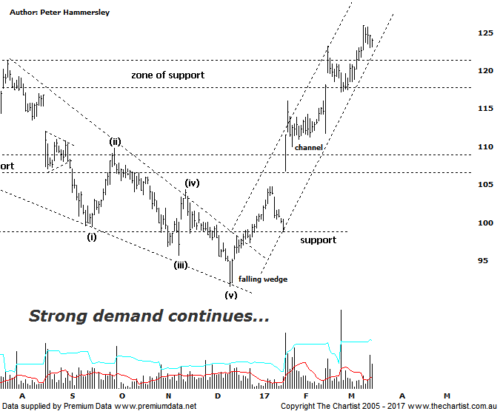

Bottom Line
16/3:
Daily Trend: Up
Weekly Trend: Up
Monthly Trend: Up
Support levels: $121.25 - $117.19 / $108.68 / $91.62
Resistance levels: N/A
Video Analysis
Watch Video Analysis Here
Technical Discussion
CSL conducts research of biopharmaceutical products. Following positive results, it continues into the development and manufacturing stages before distributing the product. It operates in three segments; CSL Behring, Intellectual Property licensing and Other Human Health. The latter consists of CSL Bioplasma and CSL Biotherapies. Recently the company has acquired the Novartis flu vaccine business now making it the world’s second largest manufacturer. Whilst this may generate near term head-winds, longer term it’s expected to increase its profile significantly and turn a loss maker into a globally competitive business. For the six months ending the 31st of December 2016 revenues increased 17% to $3.68B. Net income increased 12% to $805.5M. Revenues reflect the CSL Behring section increase of 17% to $3.06B and the Seqirus section increase of 17% to $620M. Broker / Analyst consensus is currently “Buy”. The dividend yield is 1.3%.
Reasons to remain bullish longer term (short term weakness feasible).
→ Benefiting from the plasma supply bottlenecks as CSL can increase supply.
→ Recent results impressed the market.
→ Reliability and a strong growth outlook.
→ Success in hereditary angioedema, doubling market share since 2011.
→ Progress on innovation is a highlight.
→ New product launches add to near-term growth prospects.
→ Ongoing acquisitions offer strong gains in synergy.
The falling wedge target was achieved on the day of our last review which coincided with results being presented. Although some profit-taking took hold, price only headed back to fill the small gap that had been left, where buyers once again stepped up to the plate driving price higher. The end result has been all-time highs being overcome meaning a zone of resistance has also been penetrated. This should now be acting as support during any correction over the coming weeks. Some profit-taking has started to show recently although this shouldn’t come as any great surprise. The company is looking stretched to the upside both on the daily and weekly charts with our oscillator sitting in the overbought position. However, unless bearish divergence develops this isn’t major reason for concern. The bottom line is that the trend is up, and we will continue to ride it higher. It would take a push beneath $117.00 to suggest a deeper retracement is going to unfold although ideally a few buyers will step up should price hit the zone of support. The other pattern of interest is the rising channel with the lower boundary acting as diagonal support on four separate occasions this year. Price is now posturing around the lower trend line so we need to be vigilant for demand kicking back into gear. Brokers have become a little less bullish with many moving to “hold” recommendations although this is only due to their respective targets being achieved. We’ll stick to the technical picture which still advocates higher prices, albeit a short retracement or consolidation wouldn’t come as a great surprise considering the potency of the prior trend.
Trading Strategy
We continue to hold our long position although we have tightened the trailing stop up to $117.18 which still allows plenty of wiggle room from current levels. Should this be tagged we’ll still lock in a decent profit although obviously we’d prefer the trend to continue which at this stage is our expectation. If you aren’t already involved it’s best to stand aside until another low risk entry presents itself. This could unfold during any subsequent weakness back toward the zone of support meaning it’s worth keeping an eye on the stock if you want to be involved.

