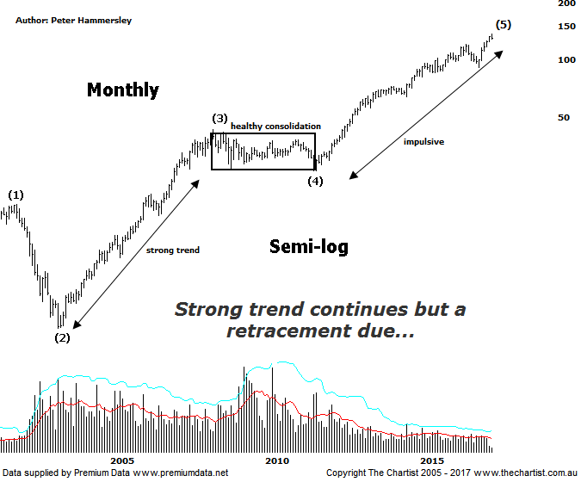

Bottom Line
28/4:
Daily Trend: Down
Weekly Trend: Up
Monthly Trend: Up
Support levels: $121.25 - $117.19 / $108.68 / $91.62
Resistance levels: N/A
Video Analysis
Watch Video Analysis Here
Technical Discussion
CSL conducts research of biopharmaceutical products. Following positive results, it continues into the development and manufacturing stages before distributing the product. It operates in three segments; CSL Behring, Intellectual Property licensing and Other Human Health. The latter consists of CSL Bioplasma and CSL Biotherapies. Recently the company has acquired the Novartis flu vaccine business now making it the world’s second largest manufacturer. Whilst this may generate near term head-winds, longer term it’s expected to increase its profile significantly and turn a loss maker into a globally competitive business. For the six months ending the 31st of December 2016 revenues increased 17% to $3.68B. Net income increased 12% to $805.5M. Revenues reflect the CSL Behring section increase of 17% to $3.06B and the Seqirus section increase of 17% to $620M. Broker / Analyst consensus is currently “Hold”. The dividend yield is 1.3%.
Reasons to remain bullish (short term weakness feasible).
→ Benefiting from the plasma supply bottlenecks as CSL can increase supply.
→ Recent results impressed the market.
→ Reliability and a strong growth outlook.
→ Success in hereditary angioedema, doubling market share since 2011.
→ Progress on innovation is a highlight.
→ New product launches add to near-term growth prospects.
→ Ongoing acquisitions offer strong gains in synergy.
It’s not often that a stock trends higher in an almost straight line movement although CSL is one of the few that has been doing just that. Since September 2011 the company has gained over 423% in value with only one decent retracement witnessed since that low was locked in. The big question now of course is how far can this trend travel. This monthly semi-log chart shows that we are technically in a position to see a significant high in the not too distant future. From the 1994 low it appears that a completed 5-wave movement shouldn’t be too far away. The problem on the lower timeframes is that the continued march higher means the wave structures don’t subdivide particularly well. This is great for momentum traders, but not ideal from an Elliott Wave point of view. What we do know is that wave-(5) shows symmetry with the prior two impulse waves meaning any further strength means what should be the final leg higher is still extending. Should recent weakness prove to be nothing more than a dip, we’ll be looking to the next possible termination point which sits up at $159.00. One thing is for sure, it would be futile to try and fight this trend and we’ll need much more evidence that a top is in position before thinking in terms of a more substantial retracement kicking into gear. We’ll simply go with the flow until signs of more serious distribution appears which at this stage isn’t the case. Dips have continued to be bought which is a trait that will be difficult to change.
Trading Strategy
We continue to hold our long position from December 2016 at $98.00 which is a strong position to be in. A couple of weeks ago we adjusted the trailing stop up to $125.90 to reduce risk which isn’t too far beneath current levels, especially after today’s decline. If we get stopped out we can always re-enter if recent weakness proves to be nothing more than a blip. One thing we don’t want to do is give too much profit back, especially with equity markets currently looking a little shaky. If you aren’t already involved it’s best to stand aside until another low risk entry presents itself.

