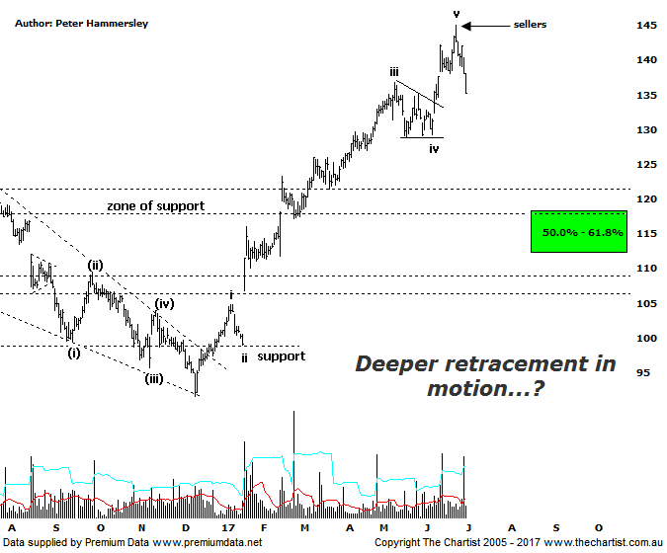

Bottom Line
3/7:
Daily Trend: Down
Weekly Trend: Up
Monthly Trend: Up
Support levels: $128.90 /$118.31 / $112.01 $108.68
Resistance levels: $145.00
Video Analysis
Watch Video Analysis Here
Technical Discussion
CSL conducts research of biopharmaceutical products. Following positive results, it continues into the development and manufacturing stages before distributing the product. It operates in three segments; CSL Behring, Intellectual Property licensing and Other Human Health. The latter consists of CSL Bioplasma and CSL Biotherapies. Recently the company has acquired the Novartis flu vaccine business now making it the world’s second largest manufacturer. Whilst this may generate near term head-winds, longer term it’s expected to increase its profile significantly and turn a loss maker into a globally competitive business. For the six months ending the 31st of December 2016 revenues increased 17% to $3.68B. Net income increased 12% to $805.5M. Revenues reflect the CSL Behring section increase of 17% to $3.06B and the Seqirus section increase of 17% to $620M. Broker / Analyst consensus is currently “Hold”. The dividend yield is 1.2%.
Reasons to remain bullish (short term weakness feasible).
→ Recent entry into the Chinese market.
→ Benefiting from the plasma supply bottlenecks as CSL can increase supply.
→ Recent results impressed the market.
→ Reliability and a strong growth outlook.
→ Success in hereditary angioedema, doubling market share since 2011.
→ Progress on innovation is a highlight.
→New product launches add to near-term growth prospects.
→ Ongoing acquisitions offer strong gains in synergy.
Back in May we looked at the monthly chart of CSL which showed that although the trend was still in full motion there was the potential for it to draw to a conclusion in the not too distant future. Although we can’t say with any high degree of accuracy that a multi-year top is in place, the smaller degree patterns advocate a deeper retracement is likely underway. The big clue will be how any retracement unfolds and whether it’s impulsive or corrective in nature. If it’s the prior, with price heading straight through the 61.8% retracement level at $112.00 we can be more certain that a significant top is in place. On the flipside, a corrective pattern down which terminates in the typical retracement zone would keep the medium-term bullish case alive and well. We often state that every stock needs to take a well-earned breather and this company fits the bill. The other reason for caution is bearish divergence although our oscillator has unwound into the oversold position on the daily chart shown here. However, on the weekly chart it’s a different story with the divergence only recently triggering. In normal circumstances, this usually means that the prior pivot high will not be overcome until our oscillator unwinds fully which on that larger timeframe is going to take several weeks as a minimum and potentially substantially longer. It would take a comprehensive break up through the recent pivot high at $145.00 to prove us incorrect regarding a deeper retracement although with the headwinds just mentioned, a probe above that level isn’t our highest expectation, at least not without first seeing a deeper retracement.
Trading Strategy
A few days ago we adjusted our trailing stop up to $136.00 which was tagged today. The end result was a profit of 38% which isn’t a bad effort within a reasonably short period of time. If a corrective pattern down appears to be the way forward we can always look to jump back on following signs of strength in the lower target area as annotated either side of $115.00. For now though, we’ll sit this one out and let the smaller degree patterns determine our next opportunity, whether it be to the up or to the downside.

