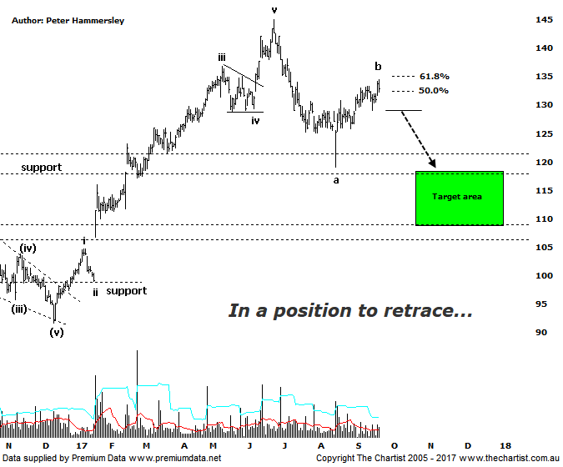

Bottom Line
21/9:
Daily Trend: Up
Weekly Trend: Up
Monthly Trend: Up
Support levels: $118.31 / $112.01 $108.68
Resistance levels: $145.00
Video Analysis
Watch Video Analysis Here
Technical Discussion
CSL conducts research of biopharmaceutical products. Following positive results, it continues into the development and manufacturing stages before distributing the product. It operates in three segments; CSL Behring, Intellectual Property licensing and Other Human Health. The latter consists of CSL Bioplasma and CSL Biotherapies. Recently the company has acquired the Novartis flu vaccine business now making it the world’s second largest manufacturer. Whilst this may generate near term head-winds, longer term it’s expected to increase its profile significantly and turn a loss maker into a globally competitive business. For the year ending the 30th of June 2017 revenues increased 13% to $6.93B. Net income increased 8% to $1.34B. Revenues highlight the CSL Behring section increase of 11% to $5.84B, the Seqirus section increase of 19% to $785.5M, the United States section increase of 18% to $2.85B and other country increases of 9% to $1.99B. Analyst consensus is currently “Buy”. The dividend yield is 1.3%.
Reasons to remain bullish (short term weakness feasible).
→ Exceptional earnings growth anticipated.
→ A solid start to the year with Immunoglobulins supply drying up.
→ Very high levels of influenza in Australia should support vaccine uptake.
→ The recent launch of Haegarda could be a potential catalyst for the company.
→ Acquiring 80% of a Chinese plasma fractionator which should provide a foothold into China.
→ Benefiting from the plasma supply bottlenecks as CSL can increase supply.
→ New product launches add to near-term growth prospects.
→ Ongoing acquisitions offer strong gains in synergy.
Both the larger and smaller degree patterns have been unfolding very nicely for CSL and this trait continues. During our last review we were looking for a bounce only, taking price up toward the $135.00 mark. CSL has now headed into the typical retracement zone with price reversing today in line with the broader market. In other words we are in a position to see our wanted leg lower. It’s also worth noting that Type-A bearish divergence is in place with price making a higher high over the past couple of days whilst our indicator has made a lower high. It’s not a textbook example as we don’t have the deep “V” that we often talk about although it’s technically in position and as such we must give it respect. Another couple of days of weakness will trigger the divergence which will provide further confirmation that an interim top is in position. Should downside momentum gather pace over the coming weeks there’s every chance that price is going to head down to our target zone as annotated. This consists of the typical retracement zone of the whole prior leg higher off the late 2016 lows. The lower boundary is made up of the wave equality projection although this is assuming today’s high isn’t overcome which is by no means certain at this early stage. It would take a push up through the 61.8% retracement level at $135.07 to suggest a deeper retracement is going to be avoided. However, even if that aforementioned level is overcome we’d still expect a larger consolidation pattern to form before the strong prior uptrend resumes.
Trading Strategy
If you are a shorter-term trader looking for shorting opportunities a setup has arisen. Wait until last Fridays low at $129.11 is overcome before jumping on with the initial stop placed just above the prior pivot high which at this stage sits at $134.51 although this could change over the coming days. As already stated, a push above $135.07 takes away from the downside potential, with pending trades then needing to be cancelled. Look to take profits around the lower boundary of the target circa $112.00 - $108.52.

