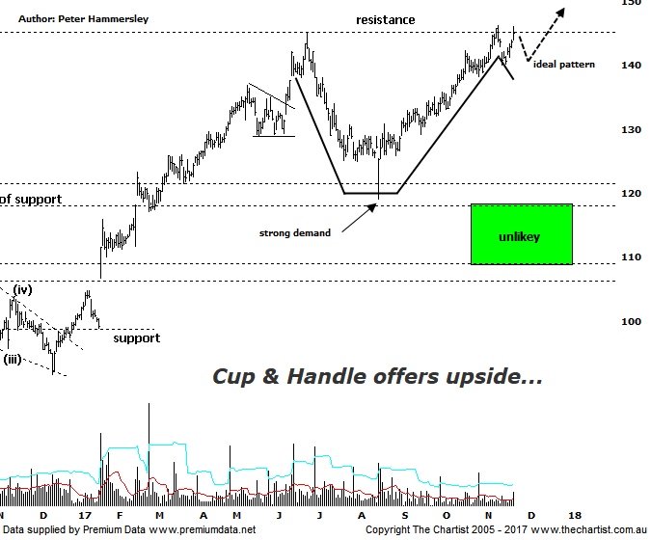

Bottom Line
22/11:
Daily Trend: Up
Weekly Trend: Up
Monthly Trend: Up
Support levels: $119.01 - $118.31 / $112.01 $108.68
Resistance levels: $146.15 (all-time highs)
Video Analysis
Watch Video Analysis Here
Technical Discussion
CSL conducts research of biopharmaceutical products. Following positive results, it continues into the development and manufacturing stages before distributing the product. It operates in three segments; CSL Behring, Intellectual Property licensing and Other Human Health. The latter consists of CSL Bioplasma and CSL Biotherapies. Recently the company has acquired the Novartis flu vaccine business now making it the world’s second largest manufacturer. Whilst this may generate near term head-winds, longer term it’s expected to increase its profile significantly and turn a loss maker into a globally competitive business. For the year ending the 30th of June 2017 revenues increased 13% to $6.93B. Net income increased 8% to $1.34B. Revenues highlight the CSL Behring section increase of 11% to $5.84B, the Seqirus section increase of 19% to $785.5M, the United States section increase of 18% to $2.85B and other country increases of 9% to $1.99B. Analyst consensus is currently “Buy”. The dividend yield is 1.2%.
Reasons to remain bullish (short term weakness feasible).
→ Volume growth expected for immunoglobulin/albumin.
→ Competitor weakness has been advantageous.
→ Exceptional earnings growth anticipated.
→ The recent launch of Haegarda could be a potential catalyst for the company.
→ Acquiring 80% of a Chinese plasma fractionator which should provide a foothold into China.
→ Benefiting from the plasma supply bottlenecks as CSL can increase supply.
→ New product launches add to near-term growth prospects.
→ Ongoing acquisitions offer strong gains in synergy.
The trend here in CSL is more indicative of a stock in the US as opposed to here in Australia. A stronger trend would be difficult to find with price now gaining 459% off the September 2011 low which is about as good as it gets for a heavyweight. A few weeks ago, we were calling for a deeper retracement although as we noted during the last review, continued buying pressure suggested a low was already locked in. Higher prices have been made over the past few weeks resulting in the all-time high made in June this year being overcome by a small margin. The patterns were lacking clarity from an Elliott Wave point of view last time and this trait has continued. The impulsive movement down to the zone of support has been followed by the same to the upside which again emphasises the lack of clarity within the patterns. However, Elliott isn’t the be all and end all of technical analysis and we can quite easily concentrate on more conventional patterns. As such, we’ve removed the wave count and we’ll concentrate on a potential Cup & Handle pattern which is something that’s been cropping up on quite a few charts over the past few months. These are strong continuation patterns and in this instance, offers plenty of upside. Ideally we’d like the handle to form for a while longer although it’s not a prerequisite to higher prices. One thing is for sure, a comprehensive break up through $146.15 in a move that sticks means the strong prior uptrend is likely back in motion. One thing we need to be aware of is that an immediate push up through that aforementioned level could present some bearish divergence on this daily chart. In other words, over the short-term there could be an attempted break out which fails initially. Just something to be aware of although it wouldn’t take away from the bullish case over the medium to longer term.
Trading Strategy
Without wanting to sound like a broken record, the potential divergence here means we can’t make a formal recommendation. However, if you like the company and want to be involved then jump on following a push above the recent pivot high at $146.15 with the initial stop placed just beneath the prior pivot low at $138.00 which provides a low risk entry. The measured move out of the Cup & handle offers a rotation up above $170.00 which offers an excellent risk/reward trade. If the divergence fails to trigger we’ll looking to put forward a recommendation shortly.

